INFO2222 Security Project Report

Group name:

RE03_Group07

Name:

Taige Liu ( SID: 480511335 )

Renfei Yu (Klaus) ( SID: 480287692 )

User Identification

We have implemented register page, feel free to Register and login. For Special User: There is a default Admin

Username: Admin, Password: Dfq123456NB

Contribution

Each Member has contributed equally in this project. Which means Renfei Yu has 50% contribution and Taige Liu has 50% contribution.

Sign to Agree:

Renfei Yu: Taige Liu:



Introduction

In this Project, we have developed a website in order to allow users sign up/sign in, Add friends, Send messages, Send post, Make Comments and have lessons. Also, our website allow Admins to manage users by adding/deleting users, mute users from post and comments. Out target group consists of students and teaching staff at The University Of Sydney.

Life Cycle Diagram

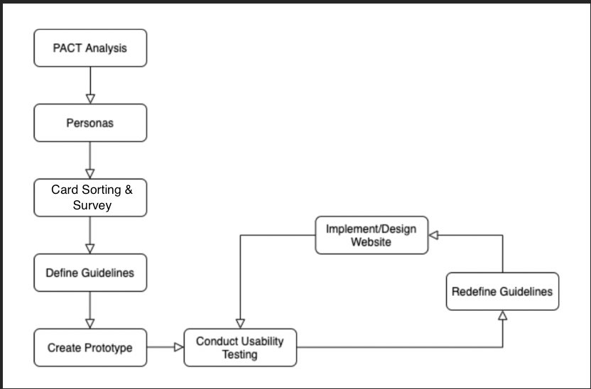

In this project, we use iterative development in order to satisfy users’ requirements and modify suggestions.

One of the main concepts of Human-centered design is iterative update, so we cannot implement the HCD with just one iteration. also we can modify the product with users’ requirements in different times since the current design may satisfies users’ requirement for now but may not satisfied users in next month (users’ Aesthetics and Requirements may change during time).

We Separate our work into several steps:

Step1: We mainly focus on conducting a PACT analysis in order to gather information that would help us create personas and design website based on the user’s needs.

Step2: Create personas based on the result of PACT analysis. We want our personas to represent our target user group.

Step3: In order to figure out what is users’ prefer design or website, we make open card sorting, closed card sorting and a survey for different users where each card represents a website component of our website. We let the user choose which features should be grouped into a category in order to help us improve the website’s usability.

Step4: From the persona and card sorting results, we will design interface guidlines.

Step5: Create a prototype from the design interface and navigations

Strp6: Conduct guerrilla Usability Testing for our prototype.

Step7: Reconstruct interface design and navigation based on the Usability Test Result.

Step8: Implement our website.

**Remind:**

Step6 to Step8 should iterative several times during the design lifecycle. Since we need to modify the product according to users’ requirements and modify suggestions.

Personas

At the start of the project, we did the PACT analysis for our website in order to determine what factors we need to consider about our interface designing. After our group discussion, we find that our target user group should be students and teaching team in The University Of Sydney.

Good persona helps designer make design decisions and reminds team about who will use the product. Also, it helps designers avoids: Elastic users – Users that morph to suit the situation

Self-referential – thinking you are the user

Edge cases – rare situations that is very unlikely to occur

In order to understand our users’ requirements and make them satisfied, we created personas from our result of PACT analysis. We want our personas to represent our target user group. So we make two groups of personas which represents Students and Teaching staff.

Group One:

**Persona**: Teaching Staff

**Fictional Name**: Jhon Blac

**Gender**: Male

**Age**: 24

**Location**: Sydney

**Education Background**: PhD Student

**Job/Major**: Software Engineering

**Brief Introduction**

He is working as a tutor in the University of Sydney and is majored in teaching IT related courses. Currently, he is assigned to a unit, and he needs to use the website to communicate with his students setting up weekly topics on the website.

**Goals and Tasks**

He is an excellent tutor and is willing to help students solving various academic problems. However, besides being as an excellent tutor in the university, he is also a PHD student who has project to work on. Therefore, he needs a user-friendly website in order to let him post new topics for the students, responds to students’ questions, and sending or receiving private messages to or from students.

**Daily Routine**

He has a good interpersonal relationship. He enjoys doing sports, singing and watching movies. As a tutor, He is very willing to help students. At the same time, he is also interested in learning new skills or trying new stuffs.

Group Two:

**Persona**: Student

**Fictional Name**: Bob Brown

**Gender**: Male

**Age**: 20

**Location**: Sydney

**Education Background**: Undergraduate

**Job/Major**: Computer Science and Computational Data Science

**Brief Introduction**

He is an undergraduate of the University of Sydney, majoring in Computer Science, mastering Java, python, JavaScript and other programming languages. He could understand a new thing or skill quickly and really care about efficiency.

**Goals and Tasks**

He is focused, goal-oriented within a strong leadership role. One of his concerns is maintaining good quality among all his units. He most of his school time doing his academic works including assignments or projects, learning new programming skills, and sharing his ideas with friends.

**Daily Routine**

He has good interpersonal relationship. He likes playing basketball, music and reading. He has participated in internships in various enterprises. He likes sharing his ideas with others on social platforms and enjoys listening to other people’s idea as well. Besides, he is also willing to participate in community activities, as well as some interdisciplinary projects.

Survey

We conduct a survey by using an online survey generator website called SurveyMonkey and have received 12 responses in total and here are the questions and the graphic expression of each question:

**Question 1**

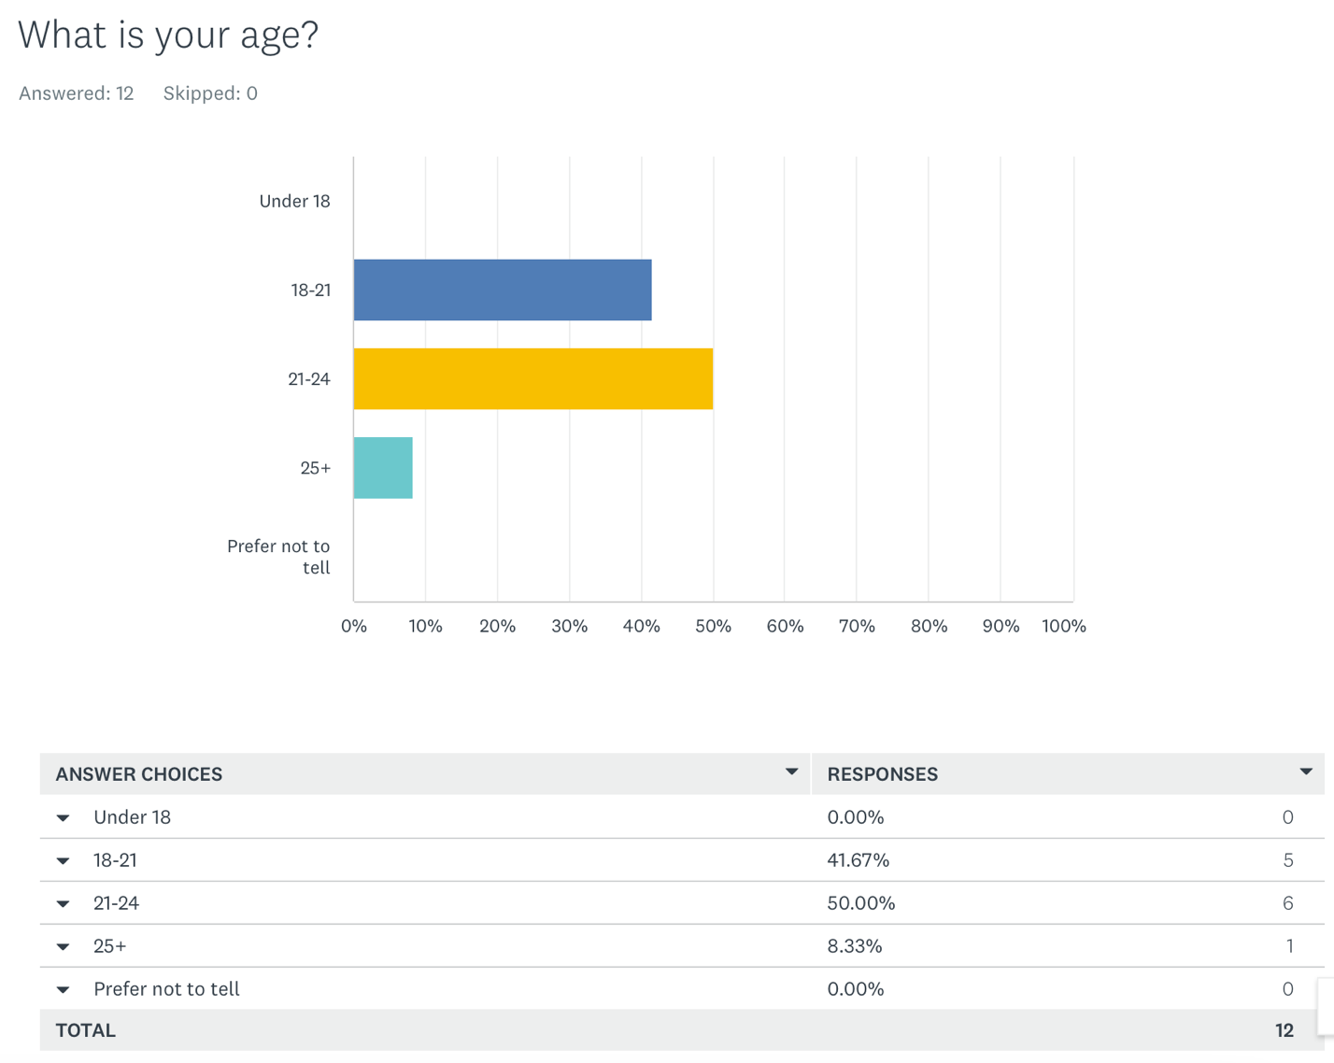

Question 2

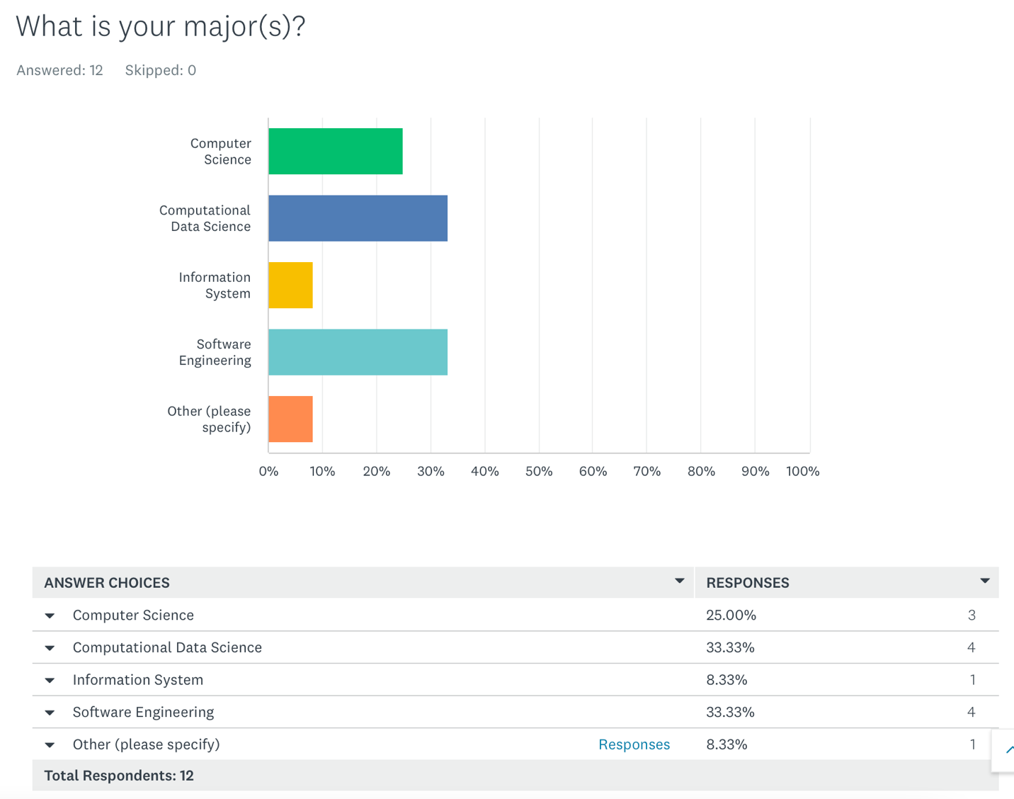

Question 3

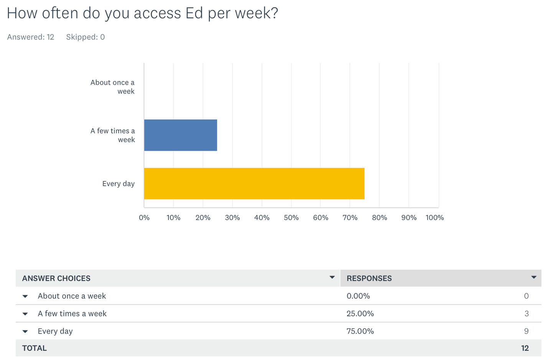

**Question4**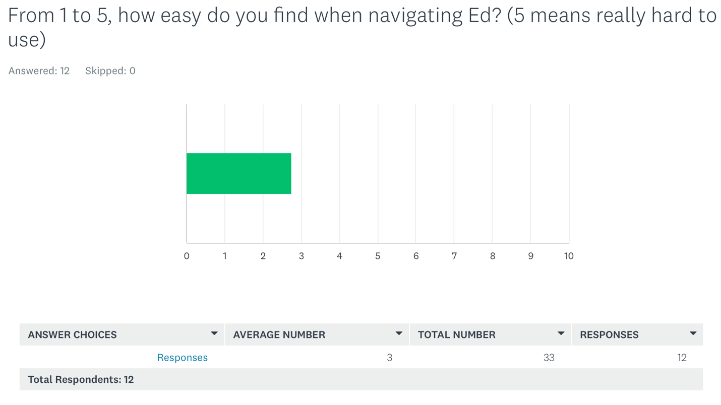

**Question5** 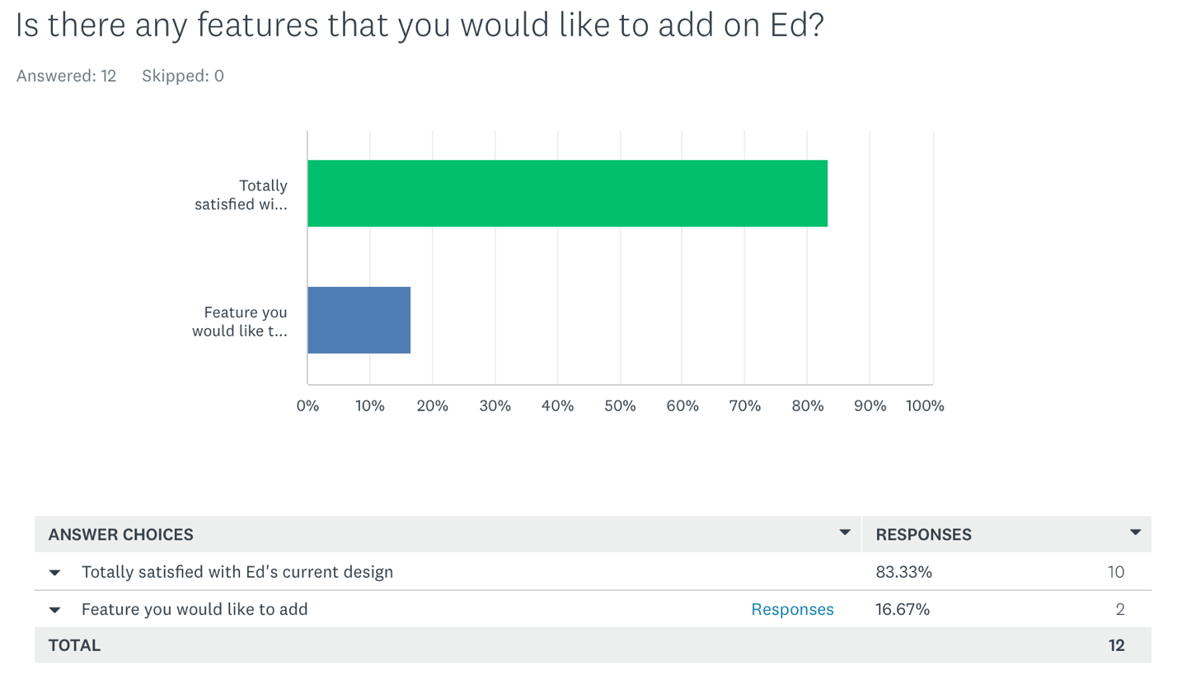

**Question 6**

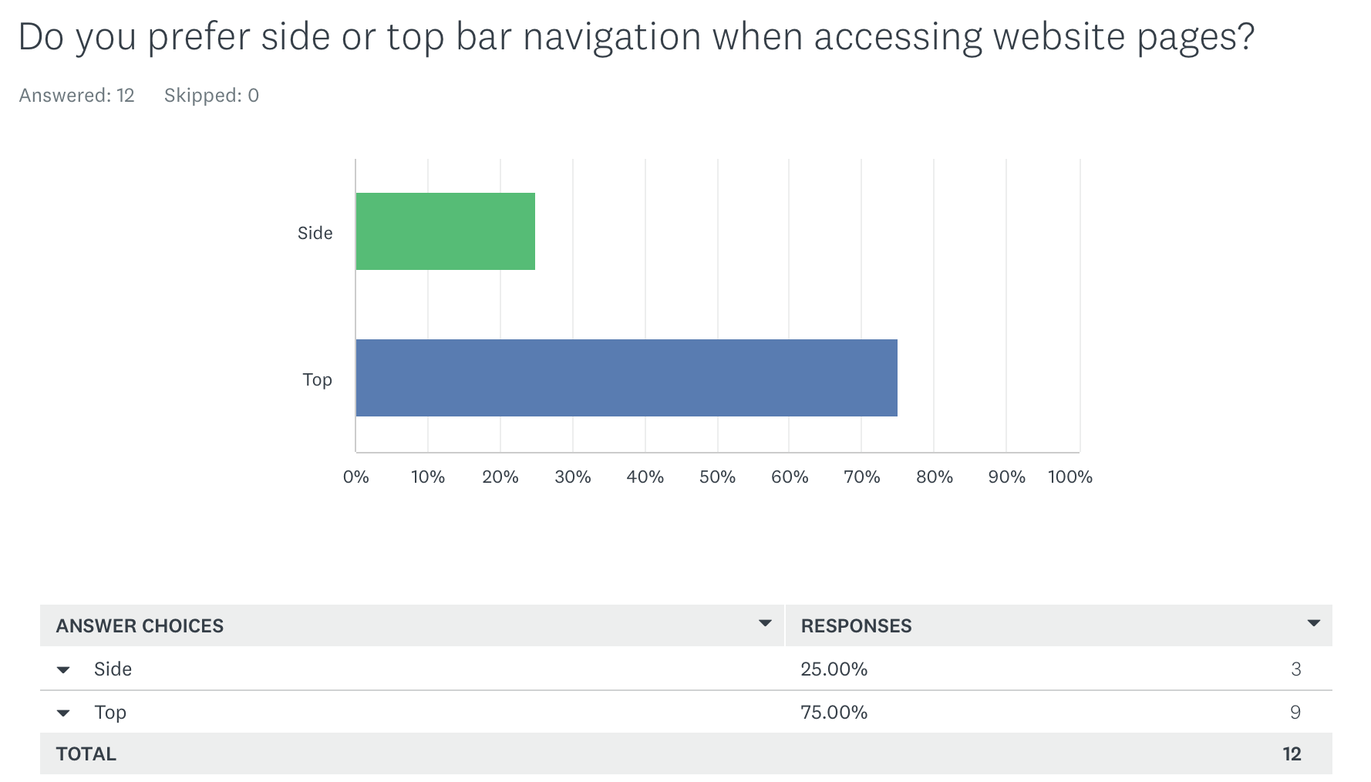

**Question7**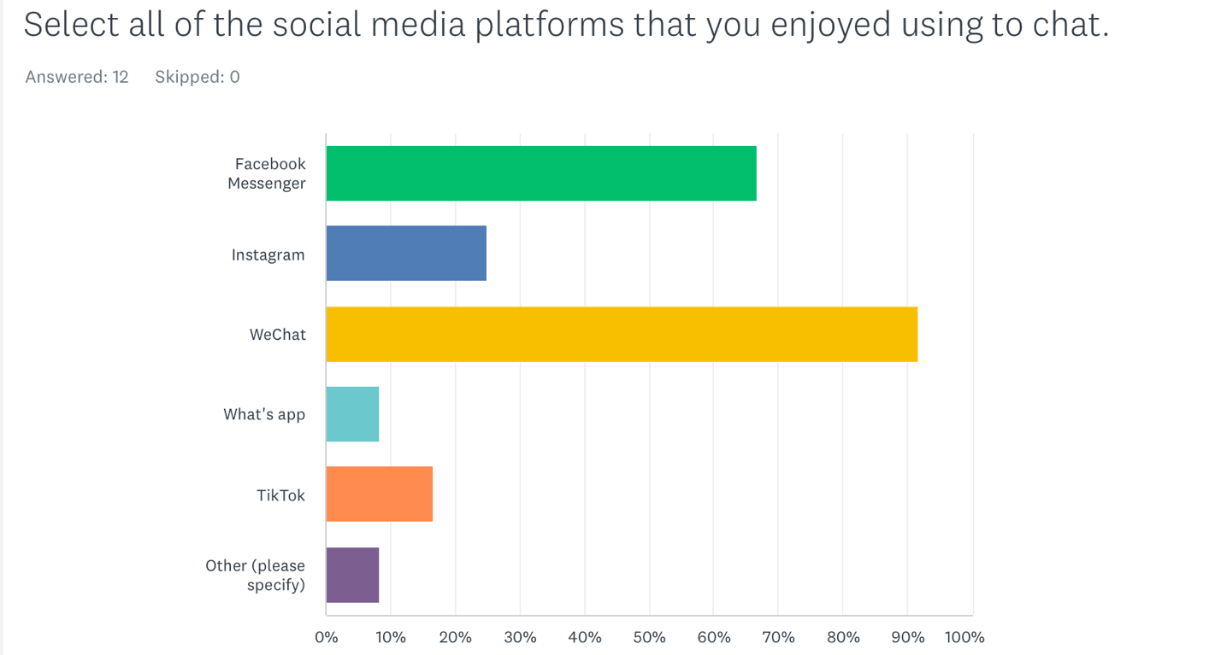

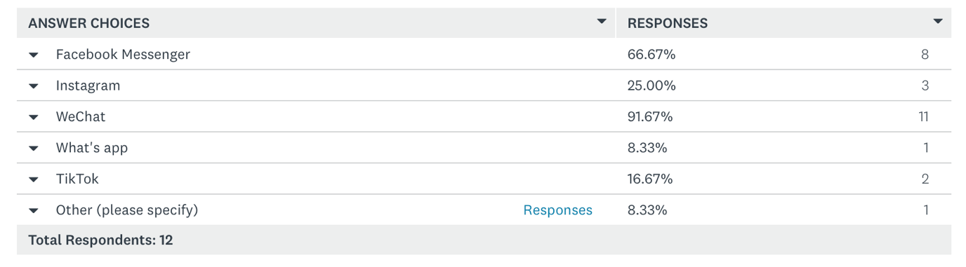

By looking through the result of our survey, we could conclude following points:

1. Most people (11 out of 12) are under age 24.
2. Most people’s major is under Information Technology branch.
3. All the participants will check Ed with a relatively high frequency.
4. Participants rate their user experience on Ed as an “ok” level.
5. Most participants think Ed don’t need to add additional functionalities and is good to use. (One participant ask for “More precise search function” and another ask for “Social Channel”)
6. 75% of the participants prefer to have a top bar navigation on the website.
7. WeChat and Facebook are the most popular social media platform for chatting.

Card Sorting

After our group discussion, we figure out that we want our website to have two more functionalities which is Forum (everyone can make posts on it and make comments on others’ posts) and Management system (Admin can manage every user by mute or delete existing user or add a new user as Admin or Normal Student. But we need to know how does users organize all our functionalities into groups.

We conduct the card sorting survey by using the website called Optimal Workshop and have received 11 responses. Due to the reason of using a free account, we could only see the first 10 responses of the result of card sorting.

**Open Card Sorting**

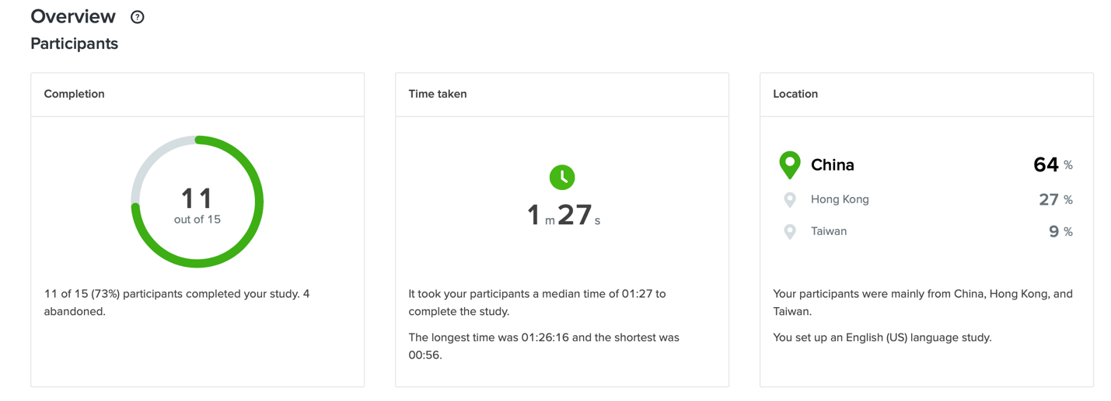

And here’s the 13 cards and the results of the first 10 responses:

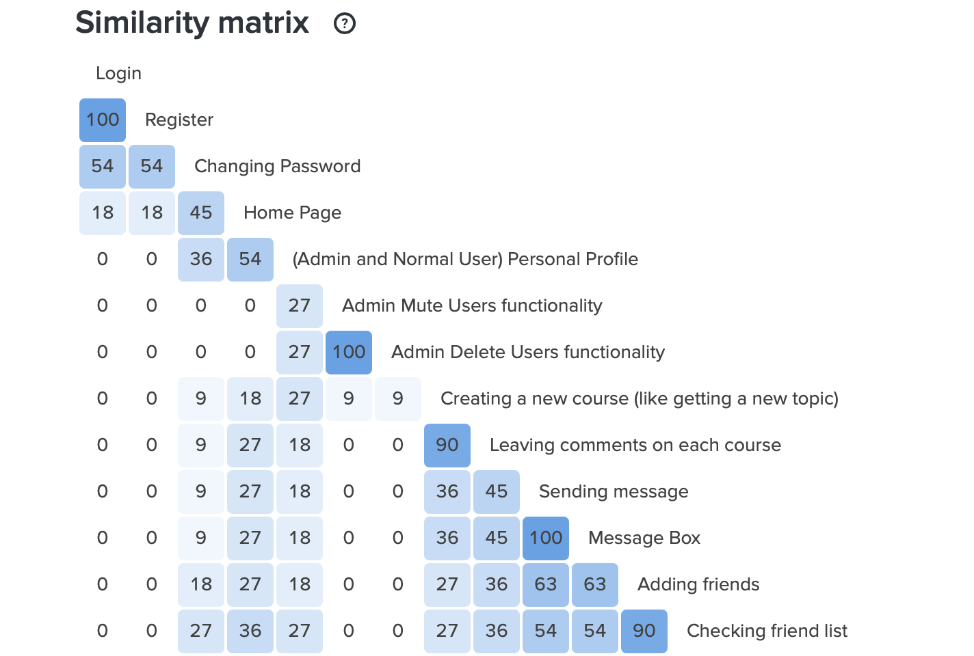

By looking through the Similarity Metrix, we could firstly conclude these five groups of functionalities must be in one web page:

1. “Login” and “Register” with 100 similarities.
2. “Admin Delete Users Functionality” and “Admin Mute Users functionality” with 100 similarities.
3. “Creating a new course” and “Leaving comments on each course” with 90 similarities.
4. “Sending message” and “Message Box” with 100 similarities.
5. “Adding friends” and “Checking friend list” with 90 similarities.

Then, putting cards with higher similarities into a group. If the similarity between two cards is higher than 50 and they are in two separate group, combine two groups into one if necessary. As a result, we get these groups:

1. “Login” and “Register”.
2. “Home Page”, “Changing Password” and “(Admin and Normal User) Personal Profile”.
3. “Admin Delete Users Functionality” and “Admin Mute Users functionality”.
4. “Creating a new course” and “Leaving comments on each course”.
5. “Sending message”, “Message Box”, “Adding friends” and “Checking friend list”.

**Closed Card Sorting**

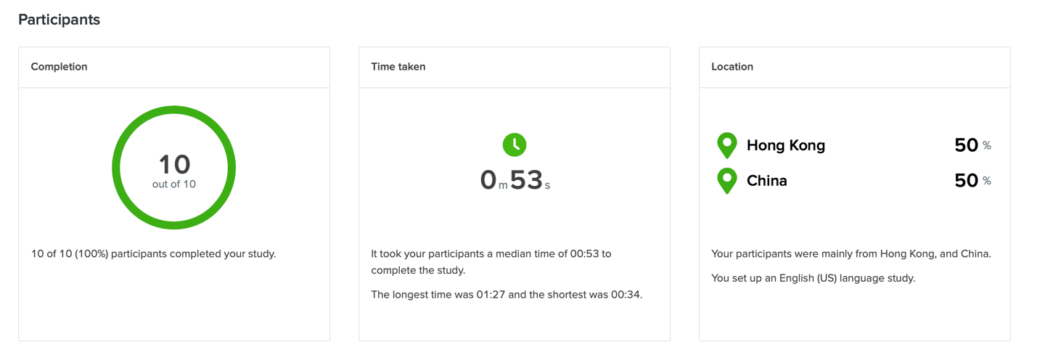

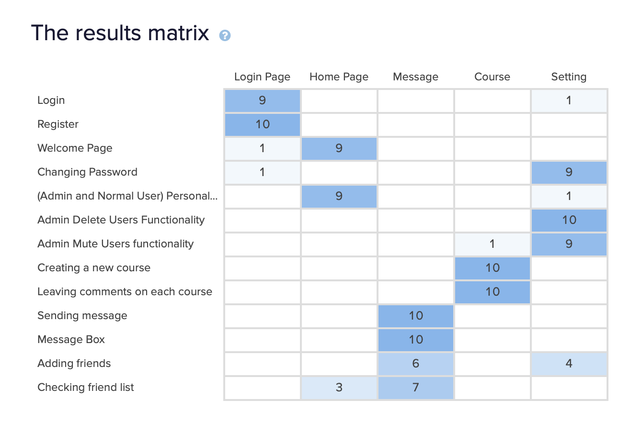

By looking at the number – representing how many times do participant put cards in each group – from the results matrix, we decide to group these functionalities like this:

* **Login Page**: Login, Register.
* **Home Page**: Welcome Page, (Admin and Normal User) Personal Profile.
* **Message**: Sending Message, Message Box, Adding friends, Checking friend list.
* **Course**: Creating a new course, Leaving comments on each course.
* **Setting**: Changing Password, Admin Delete Users Functionality, Admin Mute Users functionality

**Information architecture**

Login Page (Default Page):

* Successfully log in, jumps to Home Page.
* Failed to log, popping up warning message like “Incorrect username or password”.
* Clicking “Sign up” button leads user to the Register Page.

Register Page:

* Entering Username, Password and need to repeat the password again
* If Username doesn’t exist in the current database and the passwords that entered by the user are the same, jump to the Home Page
* If Username already exist in the current database or the passwords that entered by the user are not the same, pop-up warning message like “Username already exist” or “passwords are not the same”
* If user want to go back to the Login page, just click the “Sign in” button at the bottom of the Register Page.

Home Page:

* Welcoming words and Personal Profile like username will be shown when user entering this page.
* Top bar navigation
  + “Message” button leads user to the Message page
  + “Course” button leads user to the Course Page
  + “Setting” button leads user to the Setting Page

Message Page:

* When entering the Message page, user’s current friend list will be shown up.
* If the user wants to see the sent messages with specific friend, just click the friend’s name and the message history will be shown up.
* If the user wants to send a private message to someone, just click the “Write Message” button and jumps to the Sending Message section. In the Sending Message section, write down the target name and the message content, and then click “Send”.
  + If the target name of the sending message does not exist in the current database, a warning message will jump out.
  + Otherwise, “Sending Successfully” will jump out.
* If user wants to go back to Home Page, just click “Home” from the top bar.

Course Page:

* When entering the Course page, current course list will be shown up.
* If the user wants to enter a course topic, just click on the course name.
* Under each Course topic, if the user wants to leave a comment, just click the “comment” button, and write the comment. Then it will be shown up under the course topic.
* If user wants to go back to the Course page for checking the course list, click “Course” from the top bar.
* If user wants to go back to Home Page, just click “Home” from the top bar.

Setting Page:

* Normal User
  + User could only change password here
    - If the password and the repeated password are both entered correctly, “password has been changed!” will jump up.
    - Otherwise, a warning message will jump up instead.
* Admin
  + Admin could change password in this page as well and the steps are the same as normal users.
  + A list of current users, stored in the database, will be shown up in this page and at the end of each username, there are two buttons – “Mute” and “Delete”.
    - If click the “Mute” button, that user will be muted, and he/she could not comment or sending any message.
    - If click the “Delete” button, that user will be deleted from the database.

Define Interface Guidlines

From Our survey and Open & Closed Card Sorting result, we collected information on how users like to group functionalities and interface preference that be accepted by most users.

From the survey result, we find the interface of Ed is accept by most of the users. 83.33% interviewees are satisfied with Ed’s current design. Also, to let interviewees choose from side or top bar navigation, 75% interviewees choose top navigation, 25% of them choose side navigation bar. So we want to design or website in the structure of what Ed looks like and make navigation bar on the top.

From the card sorting result we find that 9/10 interviewees choose Login page should be in the login section, 10/10 interviewees choose to put Register in login section. So we design to make login and register function in the same page. 9/10 interviewees choose to put welcome page and personal profile in Home page Section. So we designed a user center which contains user’s profile and set the welcome page to be the default page after login successfully. 9/10 interviewees put Changing password and Admin Mute Users functionality in the Setting Section, 10/10 interviewees put Admin delete users functionality in Setting Section. So we put changing password in both user and admin’s setting page, and mute/delete functions in the Admin’s setting page. 10/10 interviewees put sending message and message box in Message sections, so we make them in the same page. Also 10/10 interviewees put creating new course and leaving comments on each course in course section, we do that as well.

Prototype Of Website:

In order to design our prototype, we use an online tool which is proto.io, Our Prototype can be access through this link:

<https://pr.to/OSC7PW/>

We also have a local html version of our prototype inside the zip file.

We created four main pages which is login, home, course and lessons. We created these pages in order to visualize the interface of the website based on design guidlines.

Prototype of Login Page

This page shows how the login page will look like. Users can login by input username and password. Also, for the new users, there is a register button below the submit button.

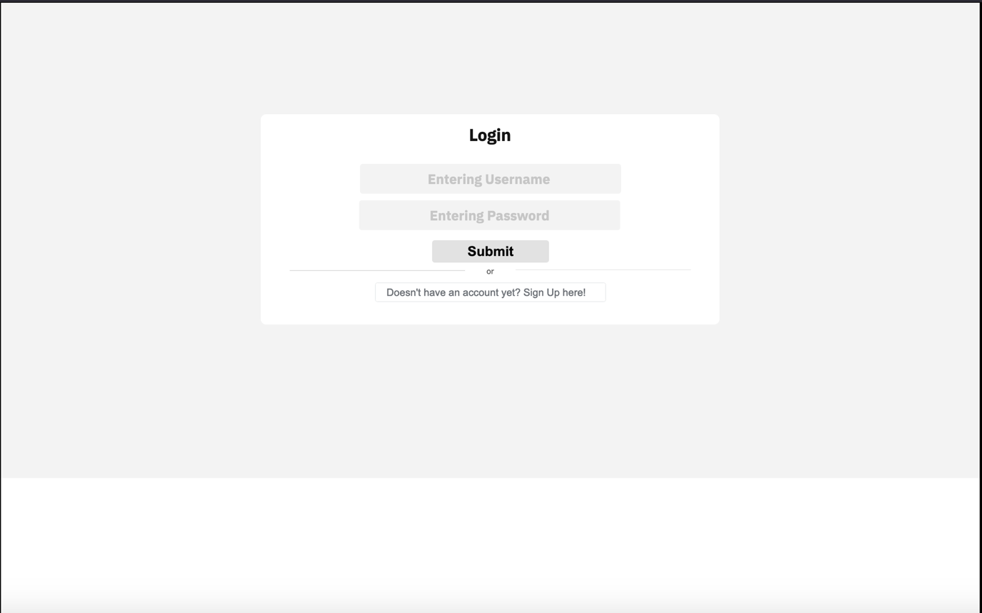

Prototype of Home Page

After users successfully login, they will get into the homepage. By default the homepage is just User’s profile page. There are four navigation bar on the top which is Home(where you at now), Course (show posts provided by users), lessons (knowledge base which been set previously) and log out (once you click, just go back to login page.

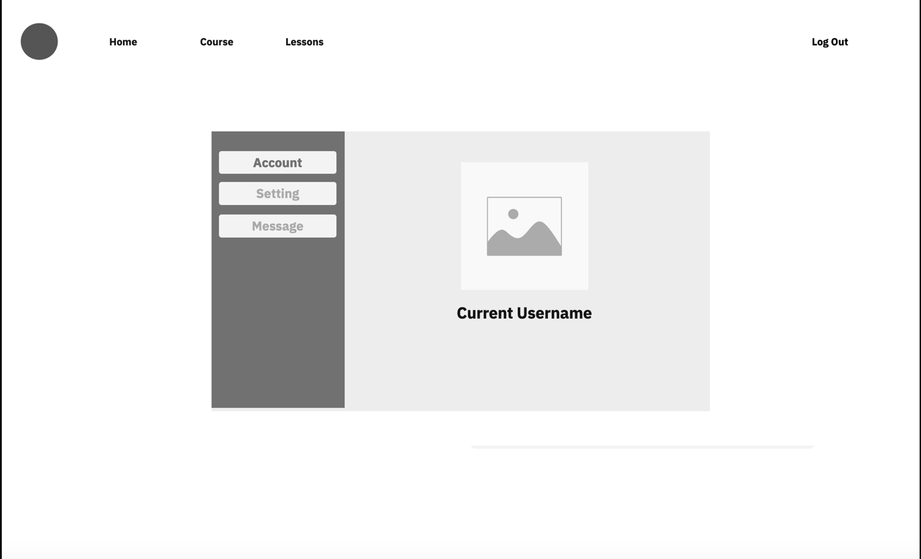

Prototype of User Center

In User center, there are three sections which are Account, Setting and Message.

The Account page shows the username of current login user.

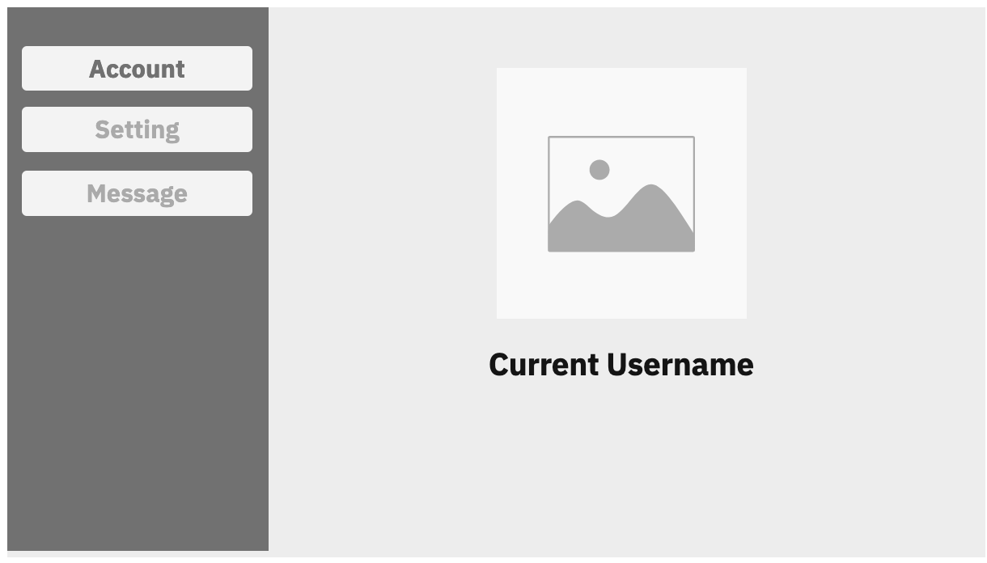

The Setting page allow users reset their password.

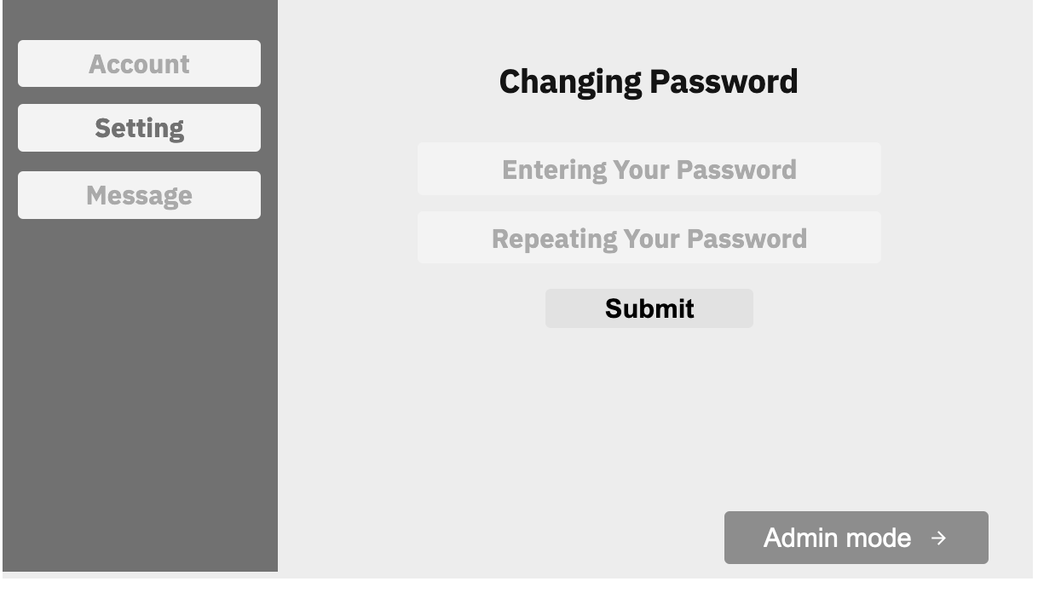

The Message page allow users to send message to each other.

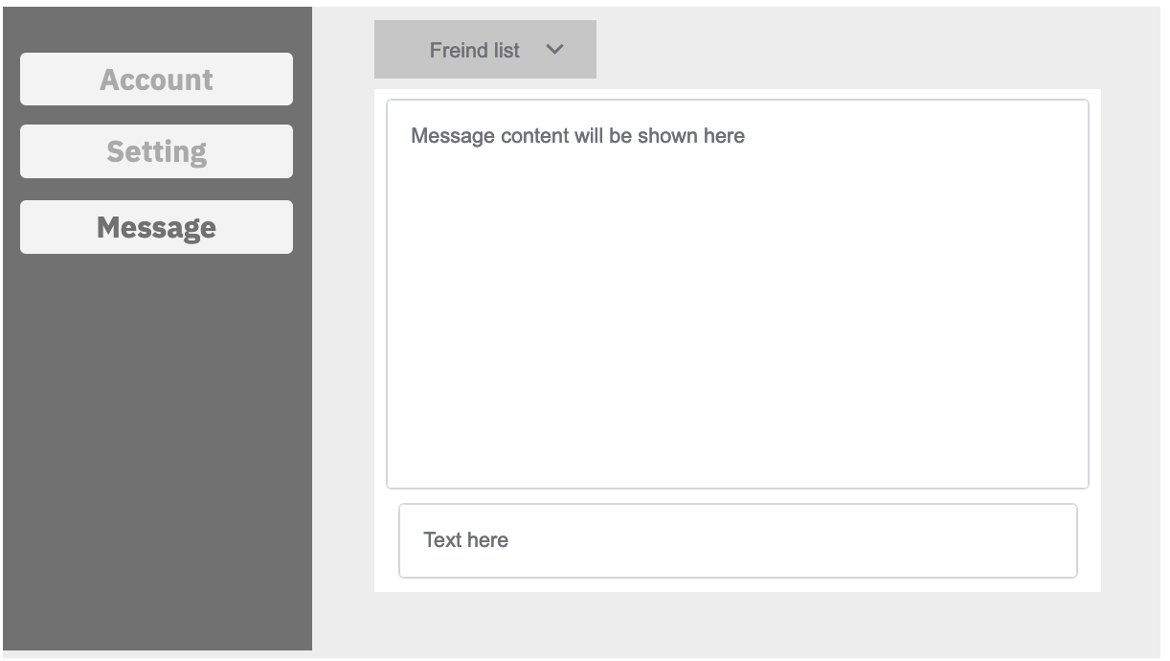

Prototype of Discussion Forum Page

In this page, users can make posts or comment existing posts.

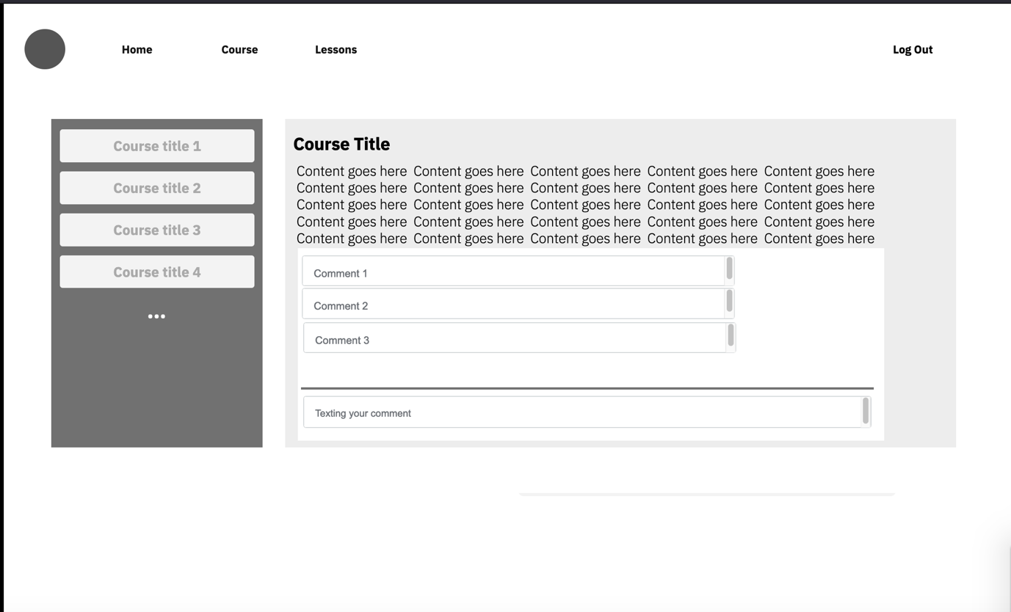

Prototype of Knowledge Base

This is the page which demonstrate lessons that been set already.

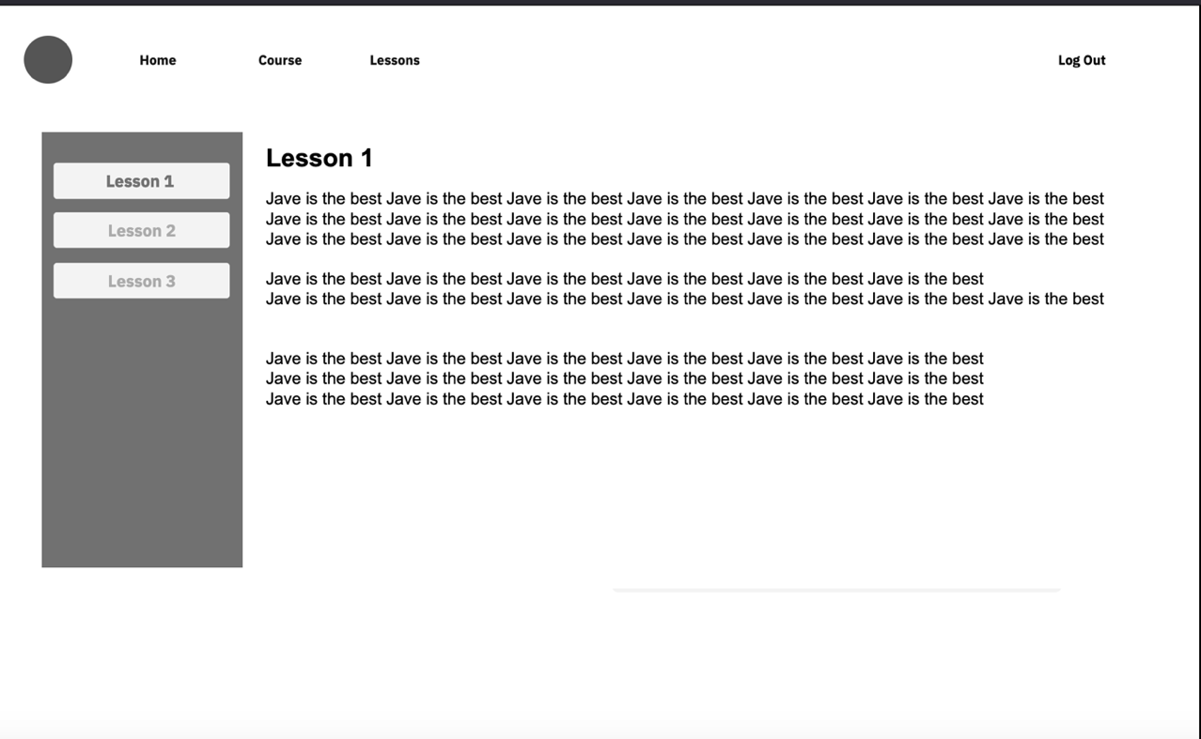

Site Map

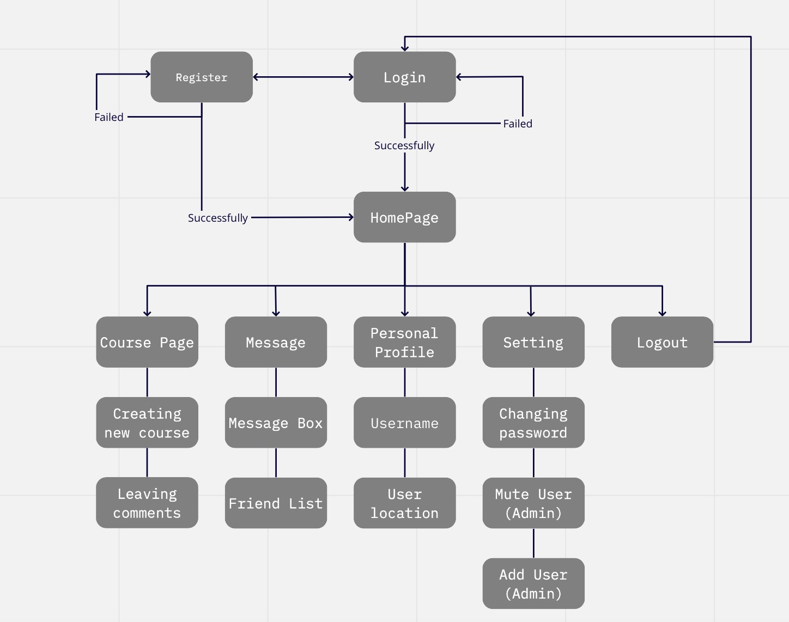

Guerilla Test Evaluation on Prototype – First Iteration

Why choose guerrilla testing?

Once we have completed our prototype, we could hardly tell if the user could access or go through the website as fluently as we - the web developer- thought. Hence, we need to use Guerrilla test to help us have a clear understanding of how our end-user think about our website and which parts of the website could be further improved.

We focused on the core features. The tasks were as follows:

1. Figure out how to register
2. Figure out how to login
3. Figure out where to change password
4. Figure out where the message list is
5. Figure out where the friend list is
6. Figure out where the lessons is located
7. Figure out where to find forum posts
8. Find the user centre from the homepage
9. Figure out where to sign out

The usability testing are taken remotely. We made the testing over Zoom and we sent the participant all of the prototypes in advance so that he can try all the functions he need. We then asked him to perform each task, and the implications were that he found most of the tasks pretty easy. Overall, users that are invited to take the guerrilla tests haven’t complain about the usability of the website, which implies that currently we do not need to concern much about the usability of the website. However, we need to re-design some of the pages, such as the Course page, as the user-experience in those pages is not good. Therefore, when constructing the actual website, we need to include less elements in Course page and adding more personal information in the personal profile section.

Implementation Phase - First Iteration

We implement the first version of our website according to the Interface Guidelines and prototype.

In Login Page, users can input their username and password to login.

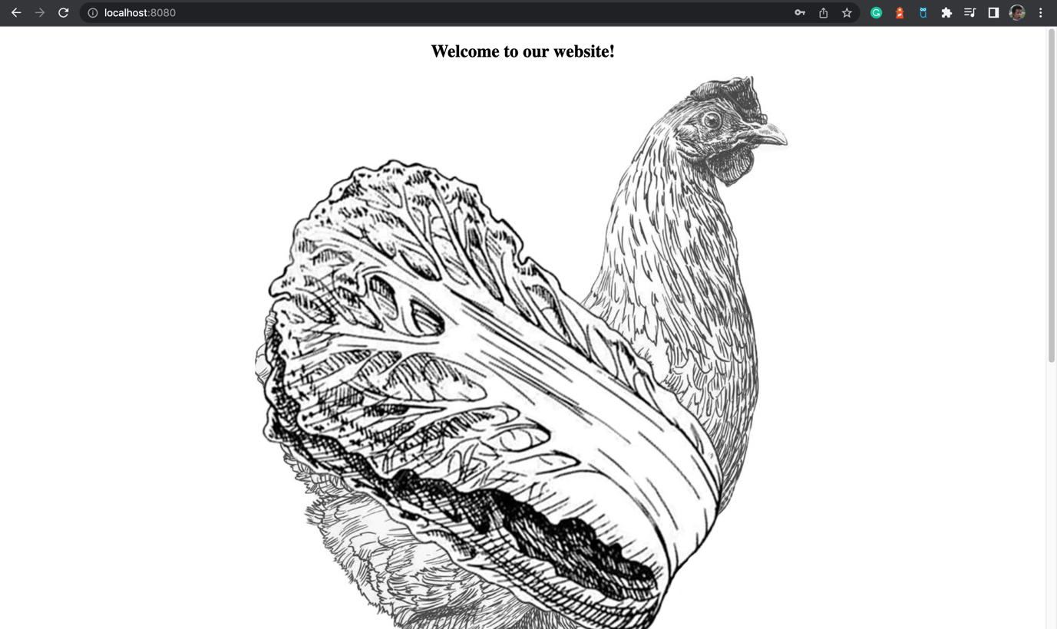

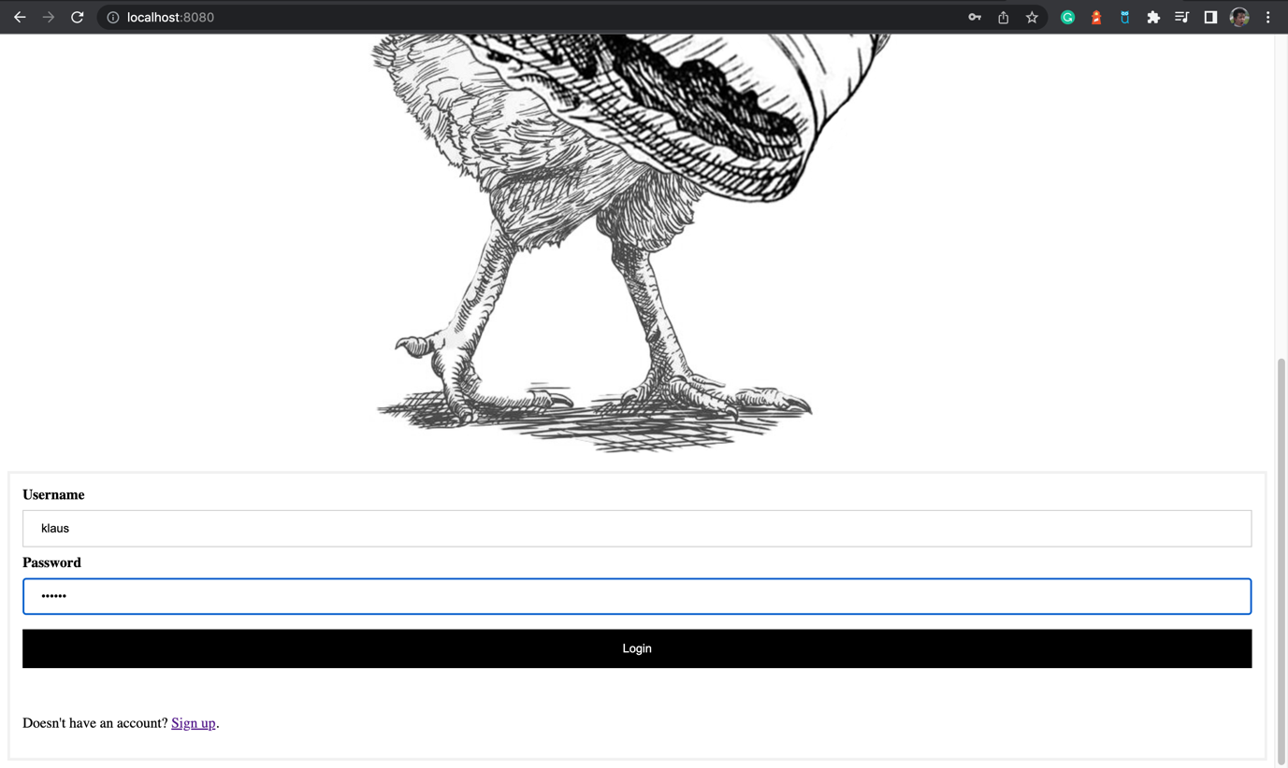

If it’s the first time that some user visit our website, there is a line of words at bottom of login page that navigate them to register which is “Doesn’t have an account? Sign up”.

If you click the Sign Up button with blue text font, you will jump to the register page.

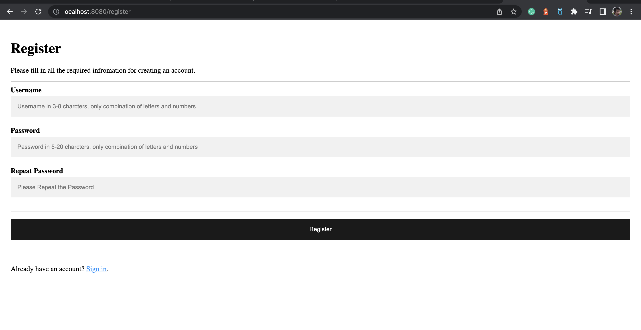

After finish register, you will be navigate to the default page which is User Profile in User center. When different users login, the following area will show different user’s name based on the Username they registered.

On the top there are four navigation button which are Forum, Lessons, Center and Log out. We are at the “Center” page right now.

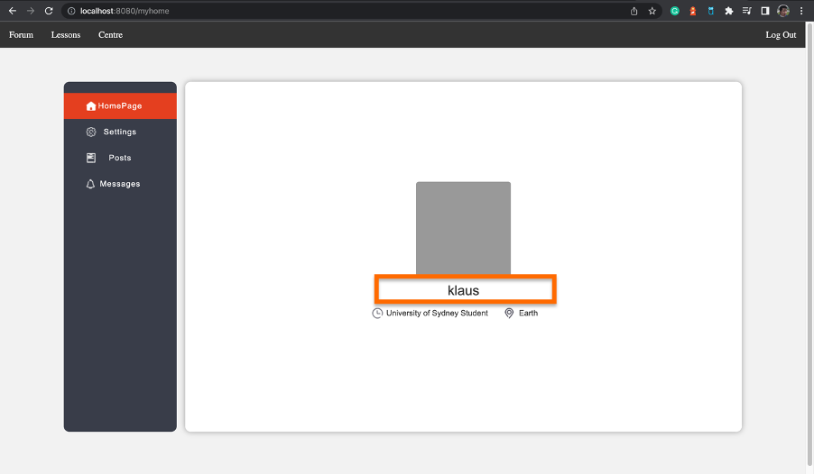

In the second section in user center, it is the settings page which allow users to reset their password.

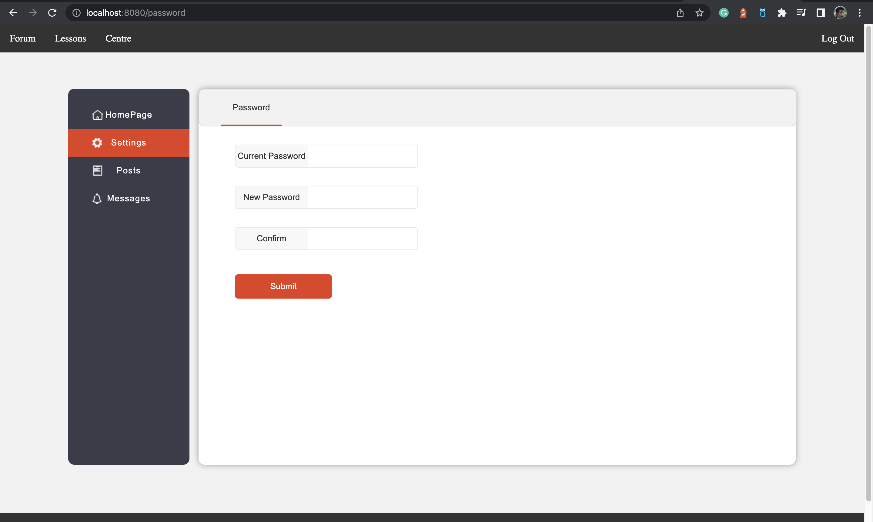

The third part is Posts, users can see the posts they made in here with title and category they defined. Also, they can delete the posts they made in this page.

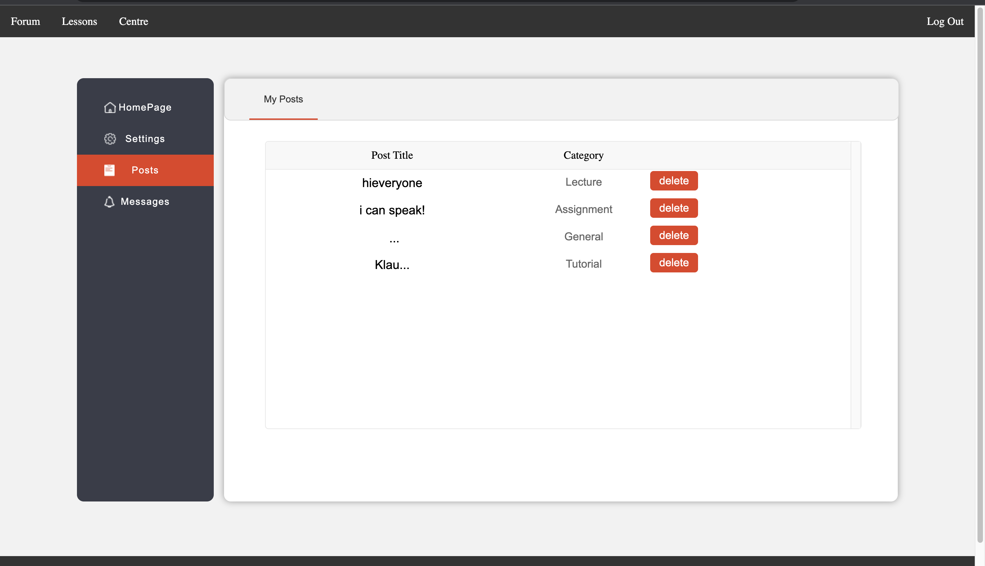

The last section in user center for normal user is Messages. In this section there are two button you can click on. The left one is “My Friend” which shows your friend list.

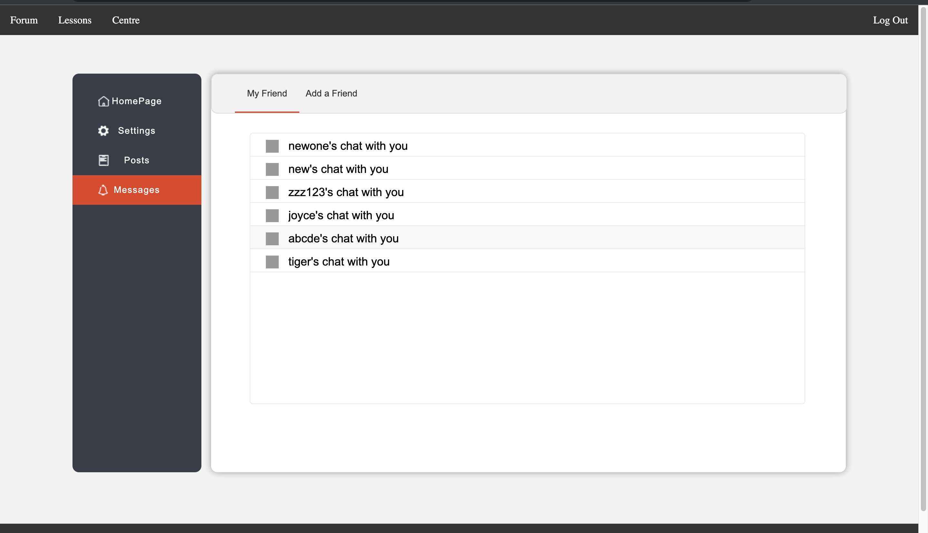

If you click on any friend’s name, it will jump to a new page which shows your chat history with the target user.

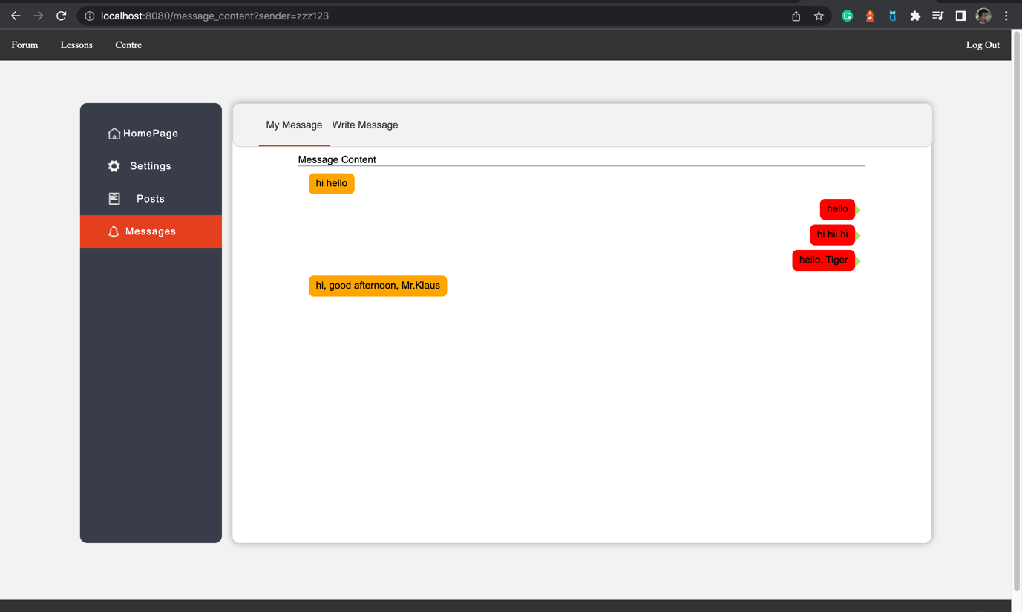

If you want to write a message, you just click on the right button on Message section.

After input the target user and content, you can send message successfully.

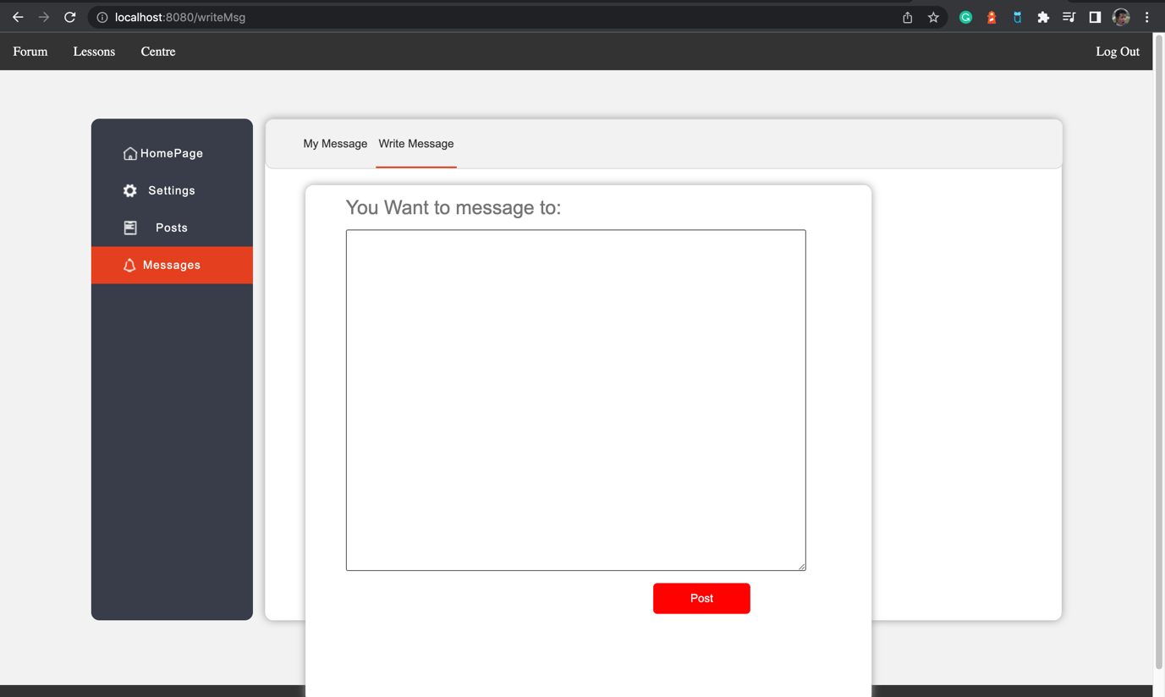

After Click on the First navigation button on the top, you will jump to the Forum page which shows all the posts made by users.

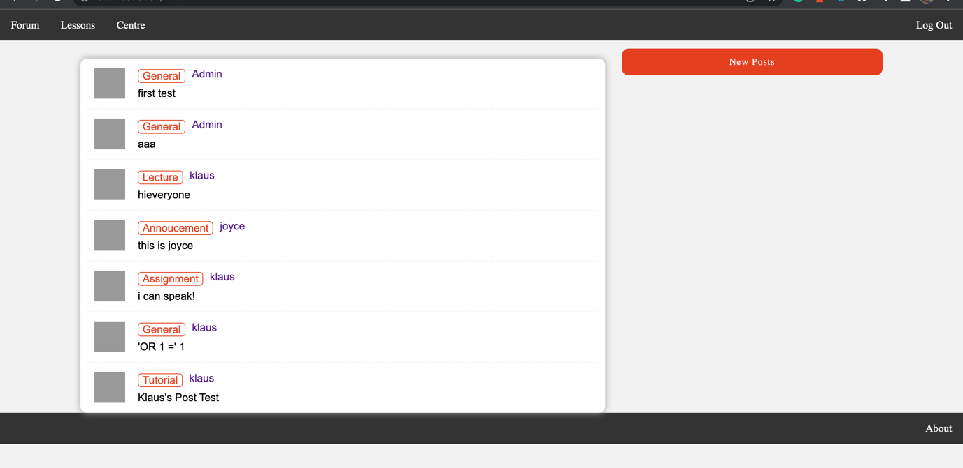

Once you click on any post, you will get into the post content. You can see the post content and all the comments. Also you can make comments by yourself as well.

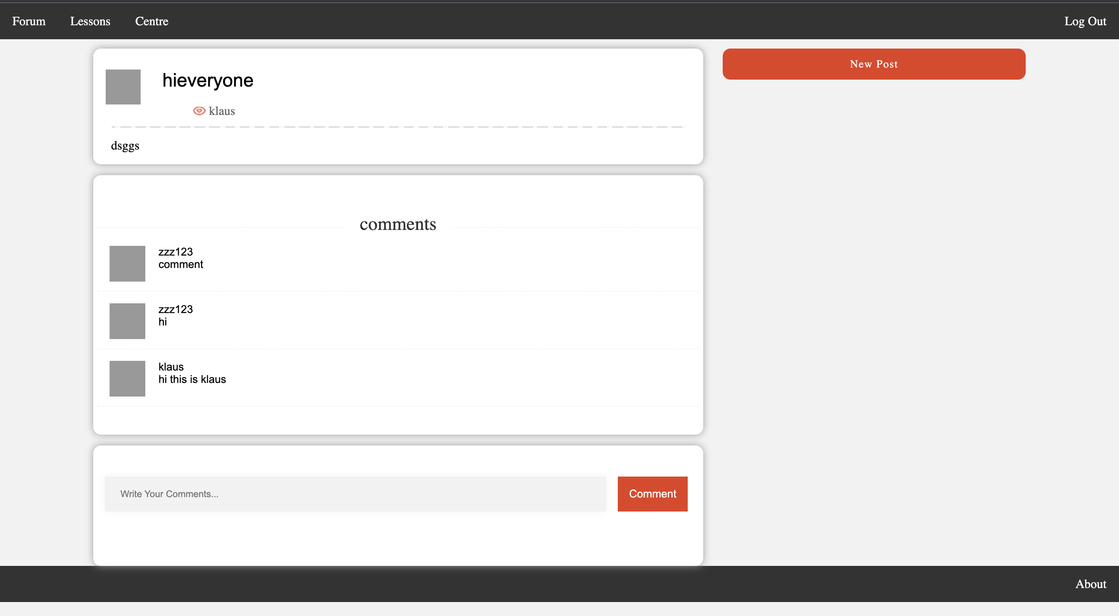

You can type comments on the text area.

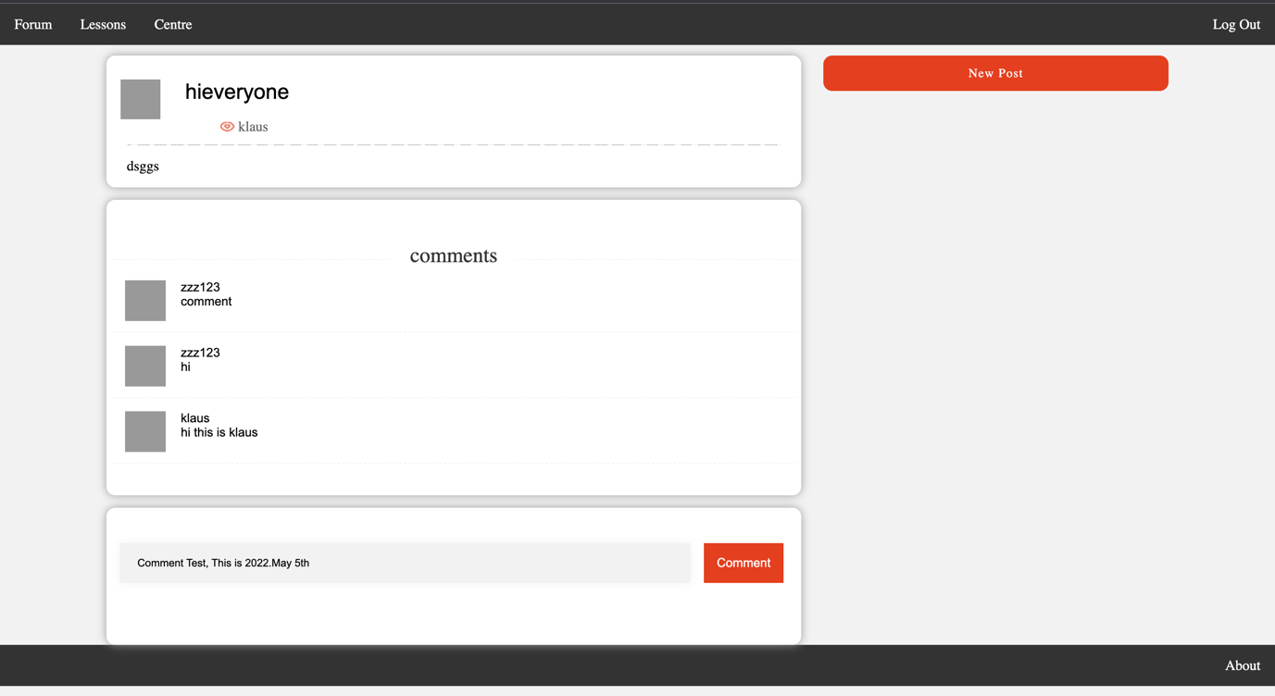

After click comment, your comment will be store in database and will be shown on the page immediately.

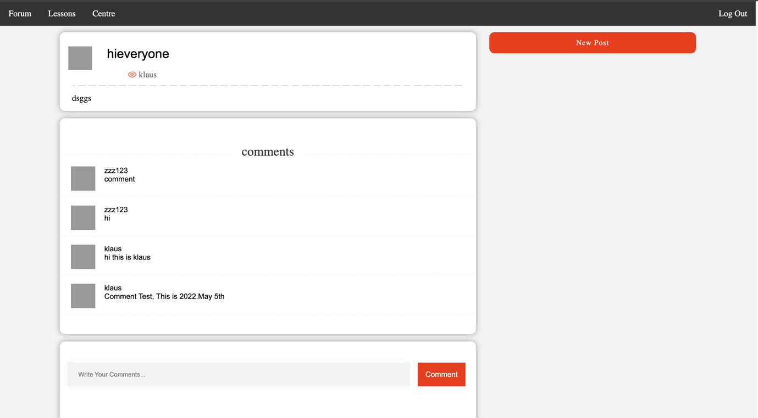

There is a New Posts button in Forum which on the right top side.

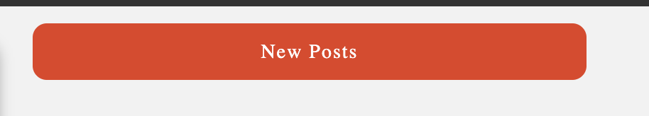

If you click this button, and you are not muted by Admin, you will jump to the page below. This is where you can make posts.

After input Title, choose the category of your posts and input contents, you can make your post. Just simple as Ed.

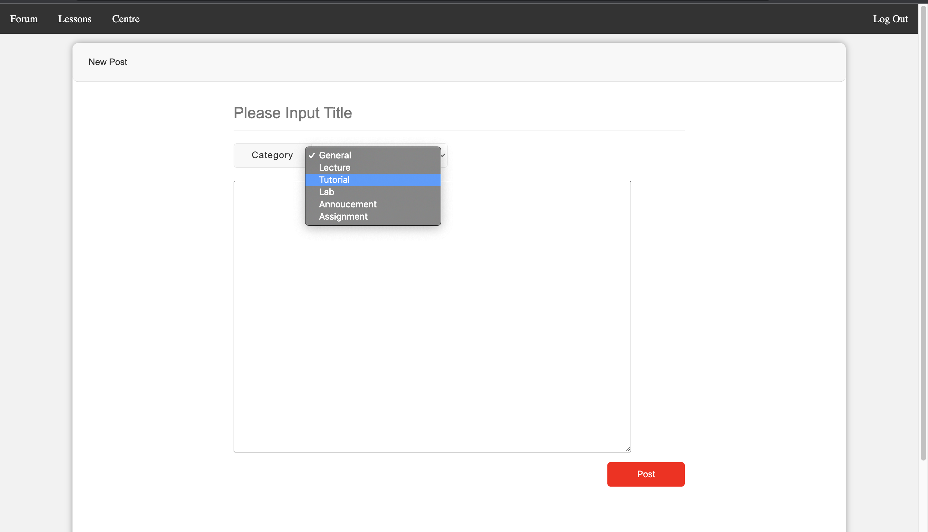

For example, when we login as Klaus and we write a post which title is “Post Test” and category is Lab.

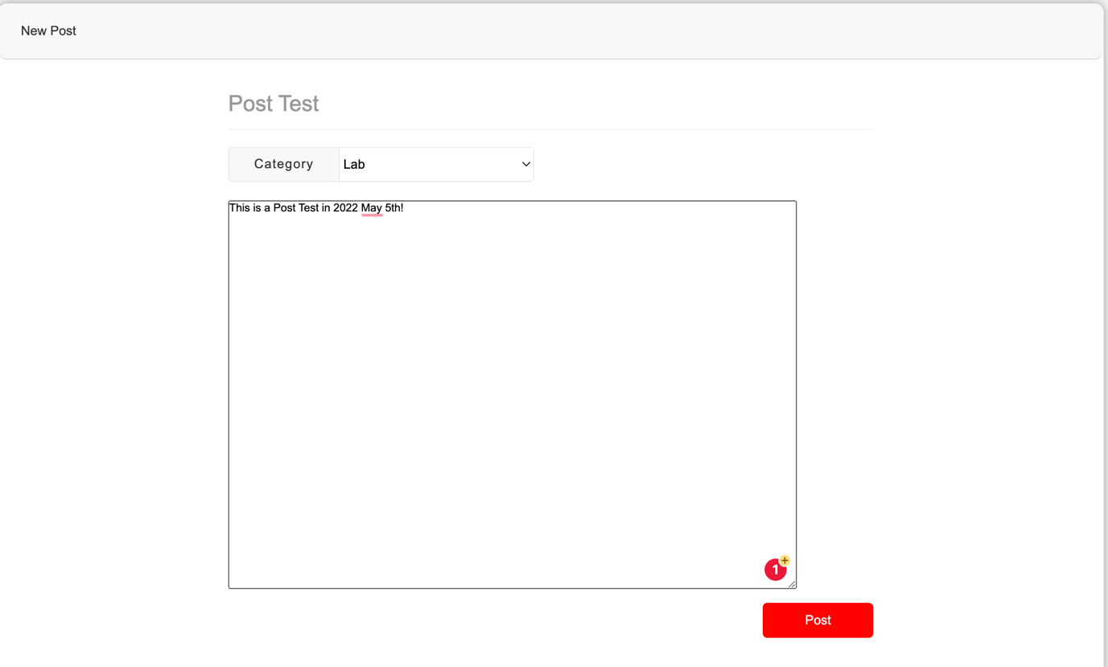

After we click post, we will jump to the posts section in user center.

Here you can see the information of the posts you made just now.

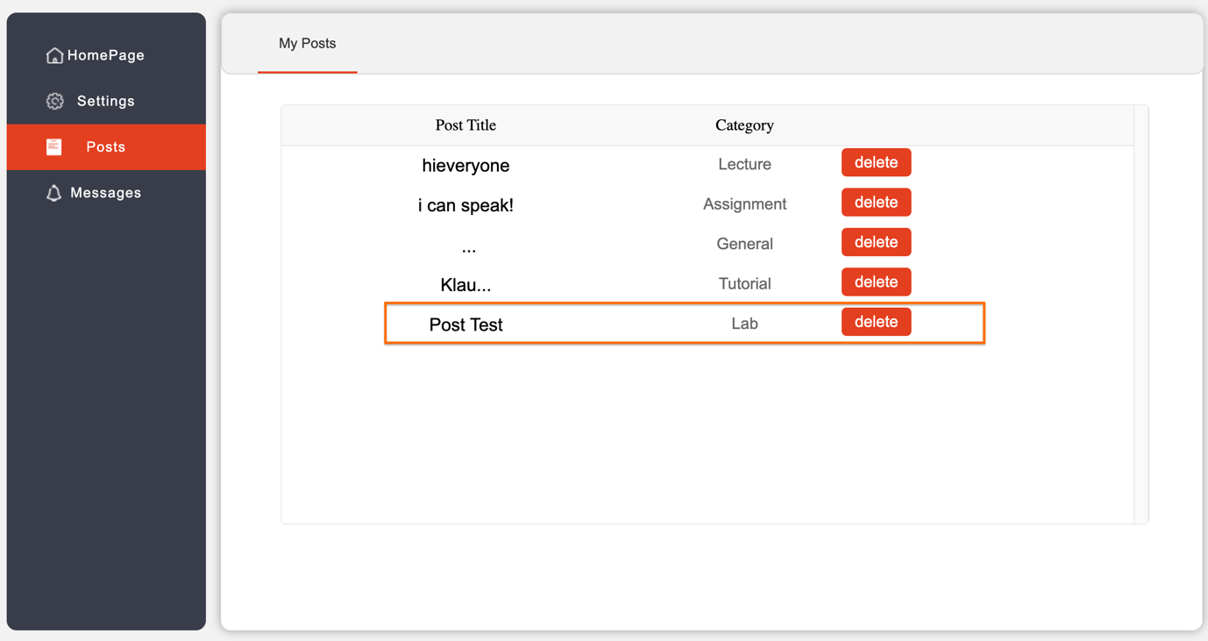

Also, in the Forum page, your posts can be seen by everyone.

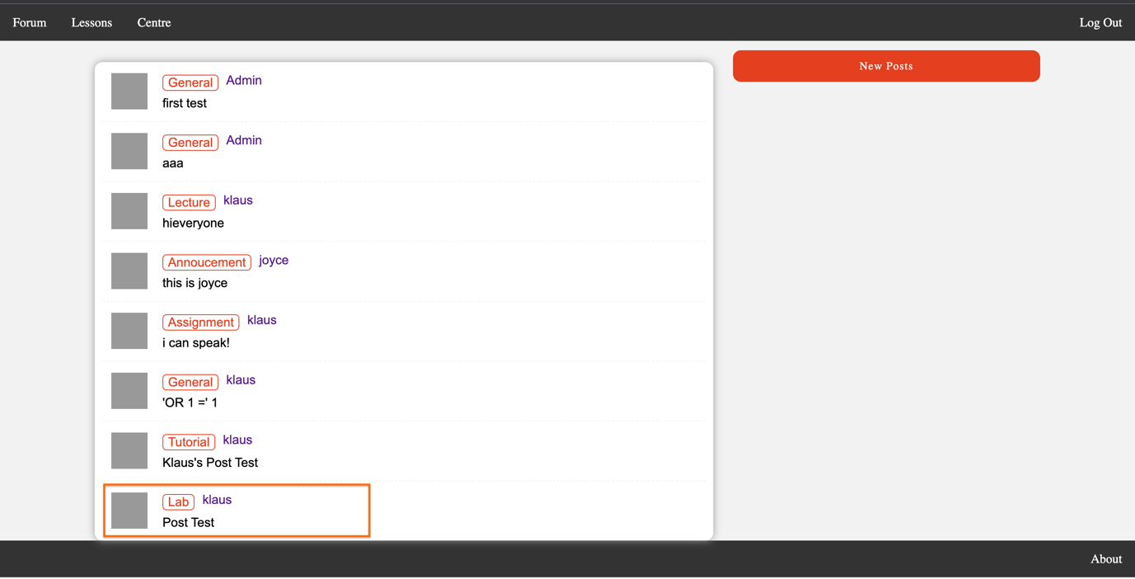

Admin

If you login as an Admin, then you will be navigated to the Admin’s Homage which has one more section which names “Modify rules”.

In this page, you will find all the user’s account and you can Add a New User, Mute a Current User or Delete a user.

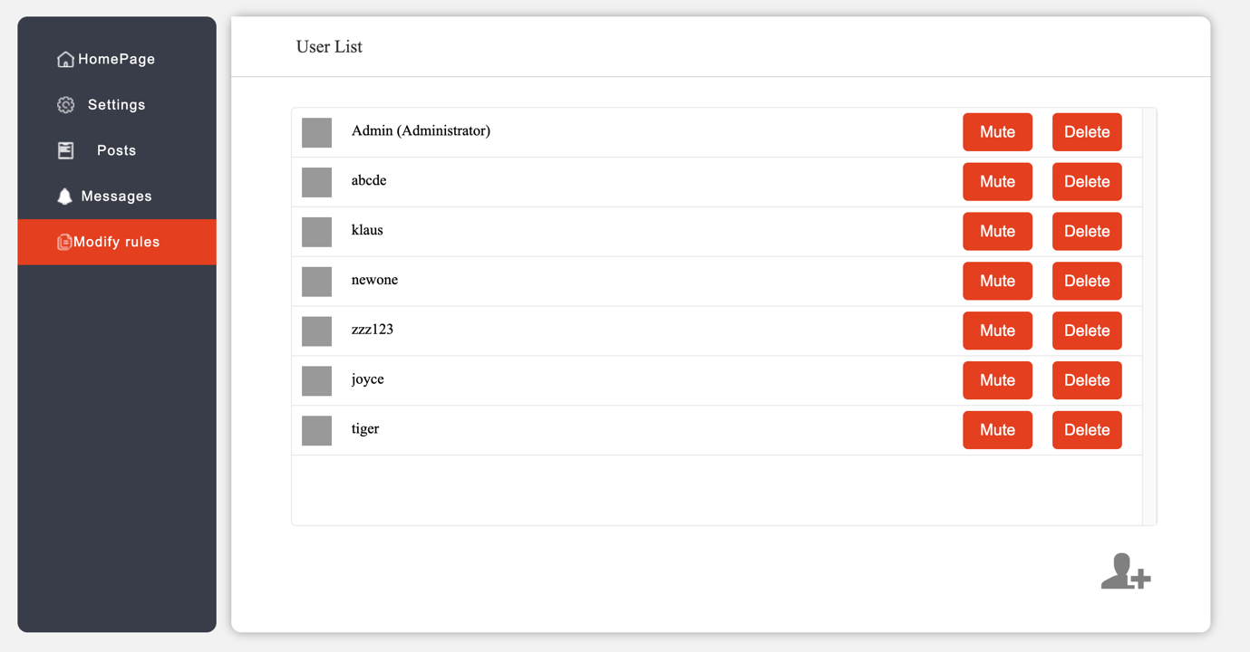

There is a button on the right bottom which is used for add new users.

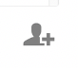

After you click this button, You can choose the user name you want to create, and you should set the password for him. Also choose the character from Student and Admin.

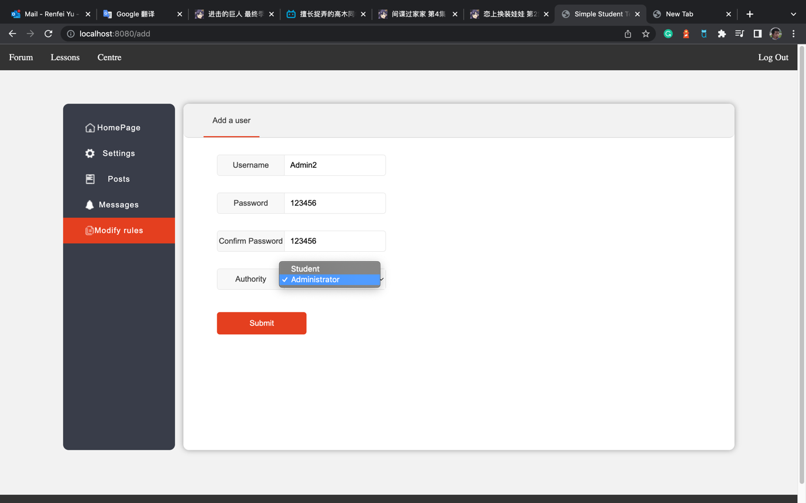

For example, we choose to add an Admin whose name is Admin2. If all inputs are legal, and click submit, there will be a popup which shows “Add user successfully!”

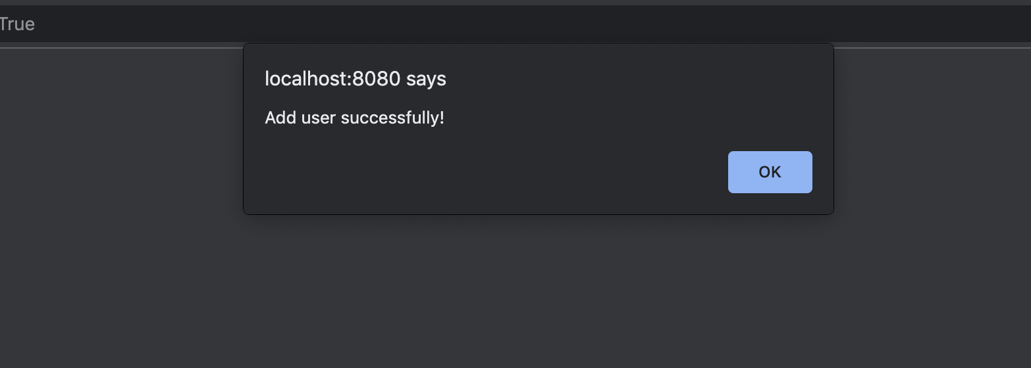

Then if you check the User List, there is one more user who names Admin2 and there is a (Administrator) after his name which represents he is an Admin.

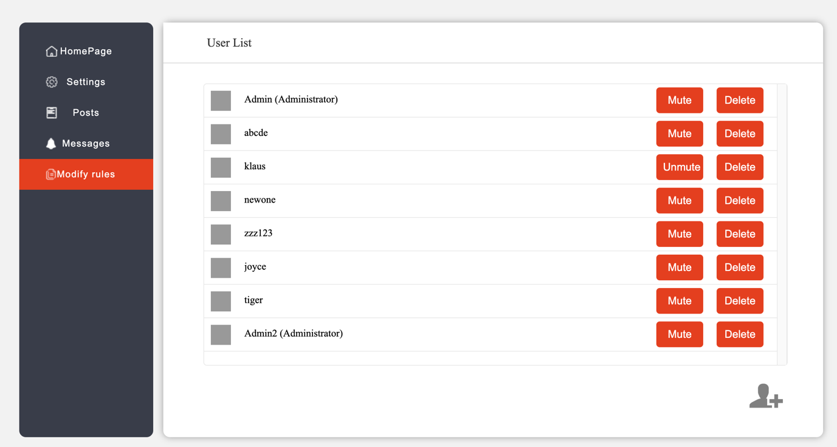

The same process for adding a new student. We name him Student2

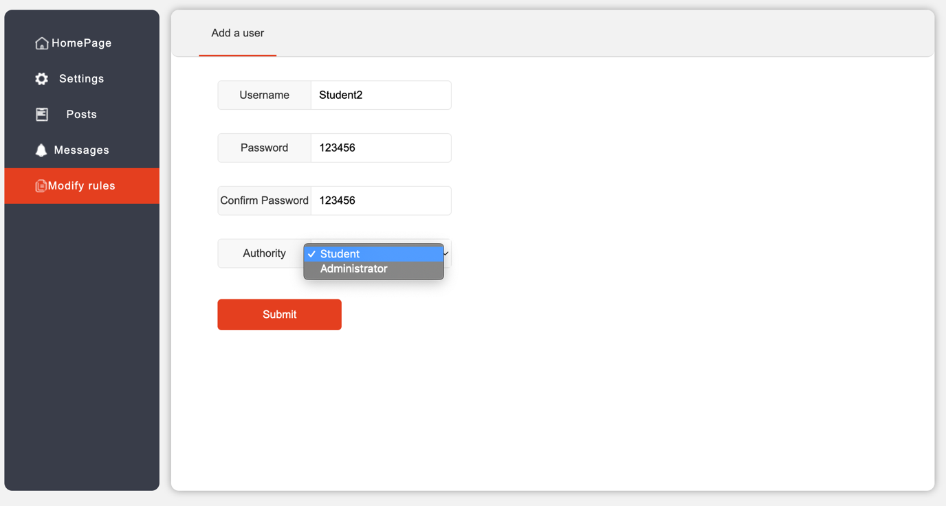

We add Student2 successfully as well.



After that, we can find there is a new user who called Student2

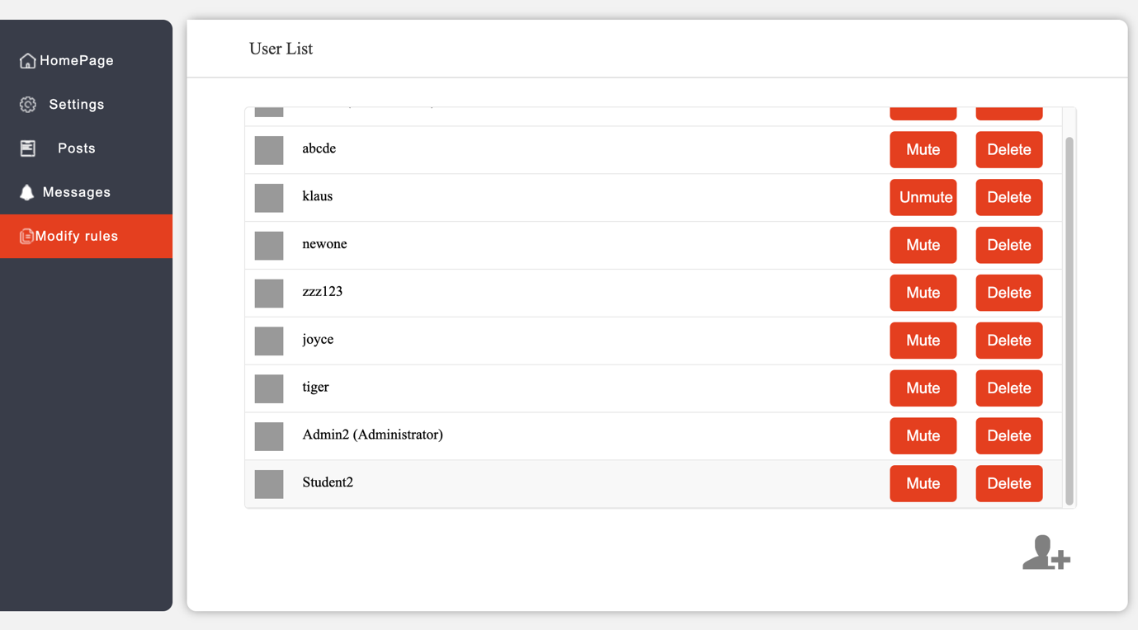

If we want to delete a user, we simply click the delete button on the right side of that user’s username.

And there will be a popup that reminds you if you are sure to delete him/her.

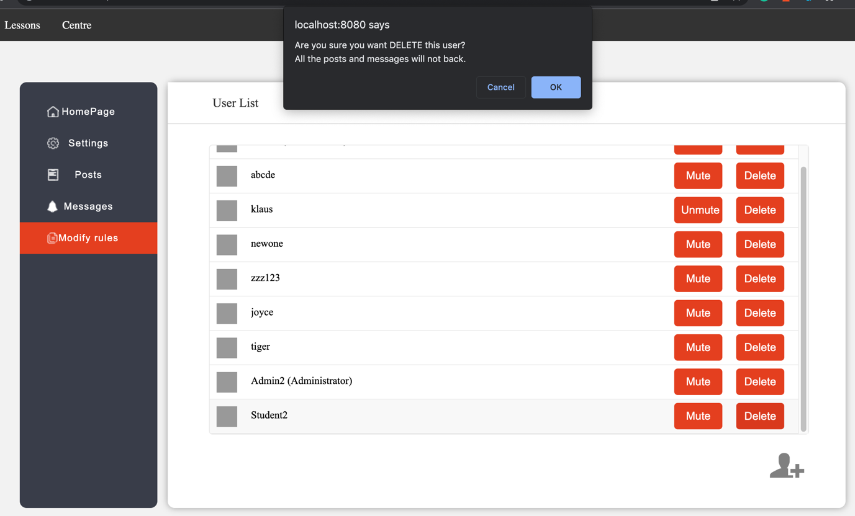

After you confirm, that user will be deleted from our page and database.

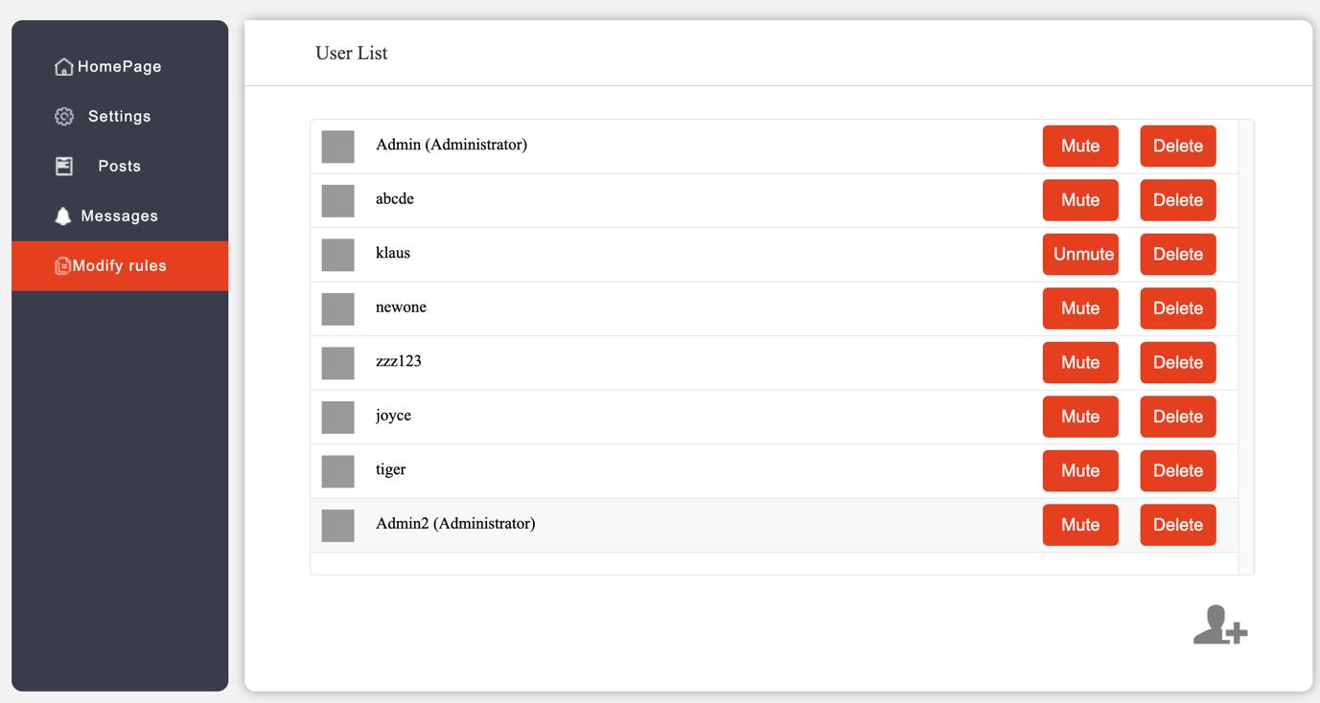

If you want to mute someone, for example Klaus. You can click Mute button on the right side of Klaus.

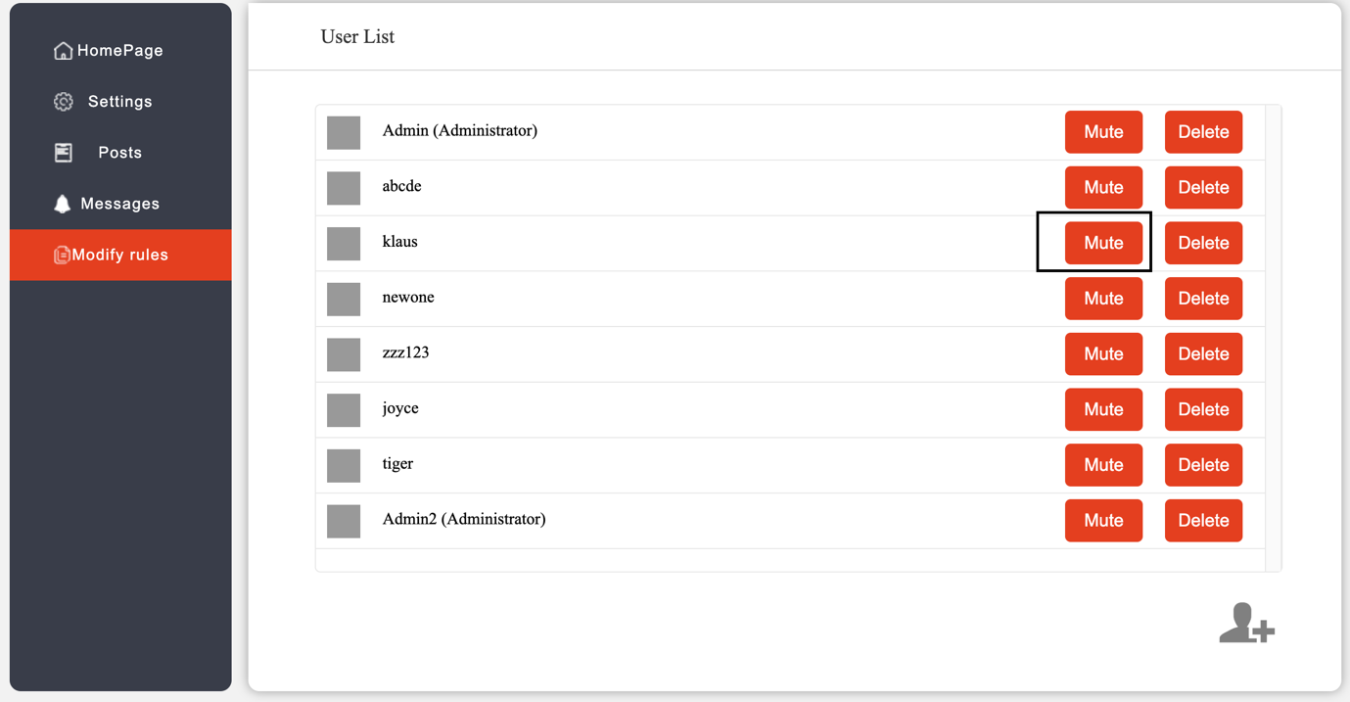

The you will find the button has changed to unmute which means you mute him successfully.

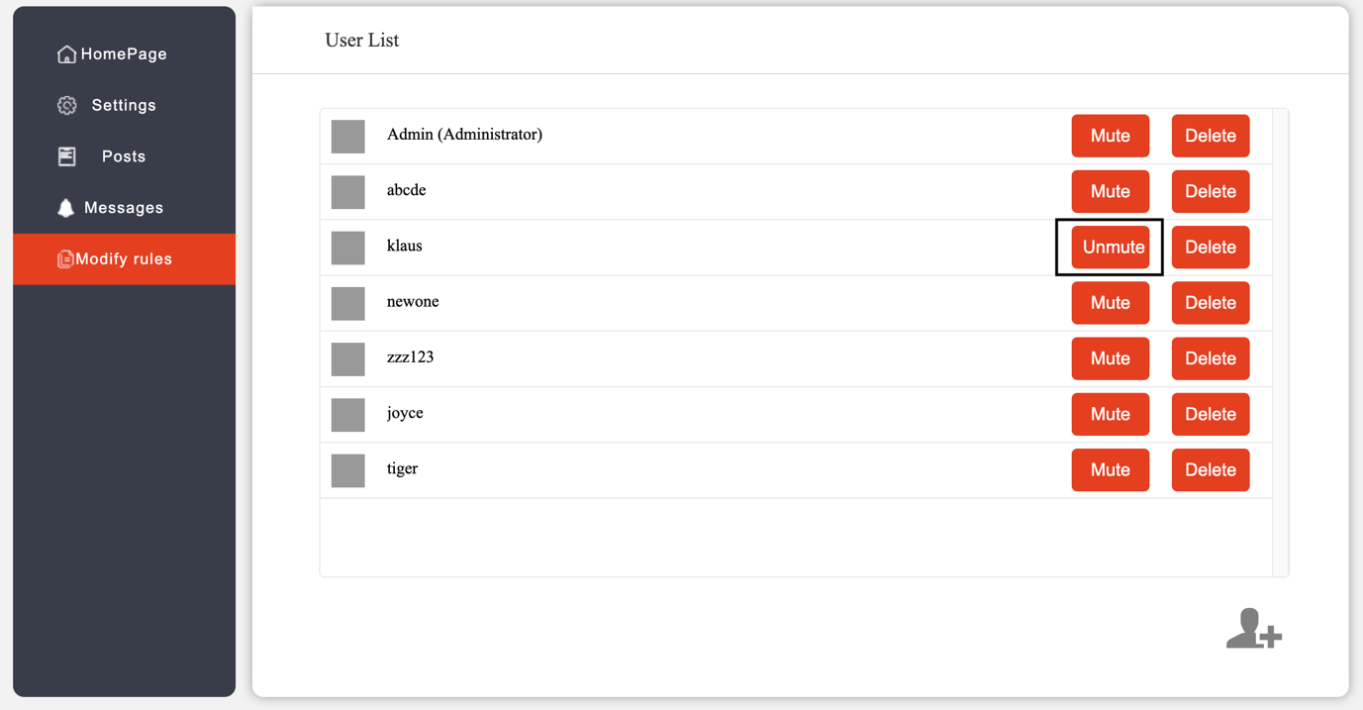

After Klaus been mute, if he login and make posts by the New Posts button.



There will be a popup shown which reminds him that he has been muted by the Admin.

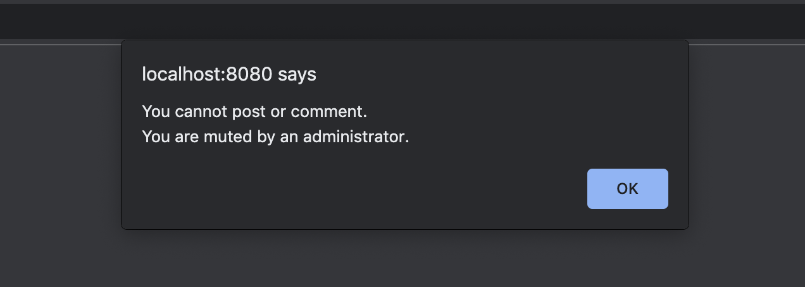

In the Lessons page, there are several lessons inside each link.

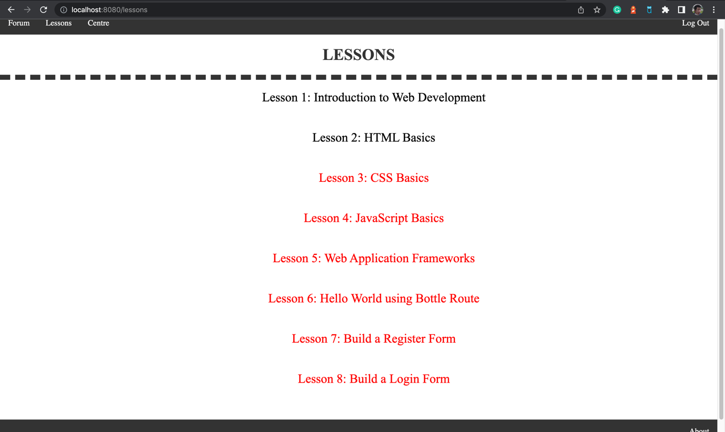

If you click on the lessons button, you will jump into the target lesson’s content.

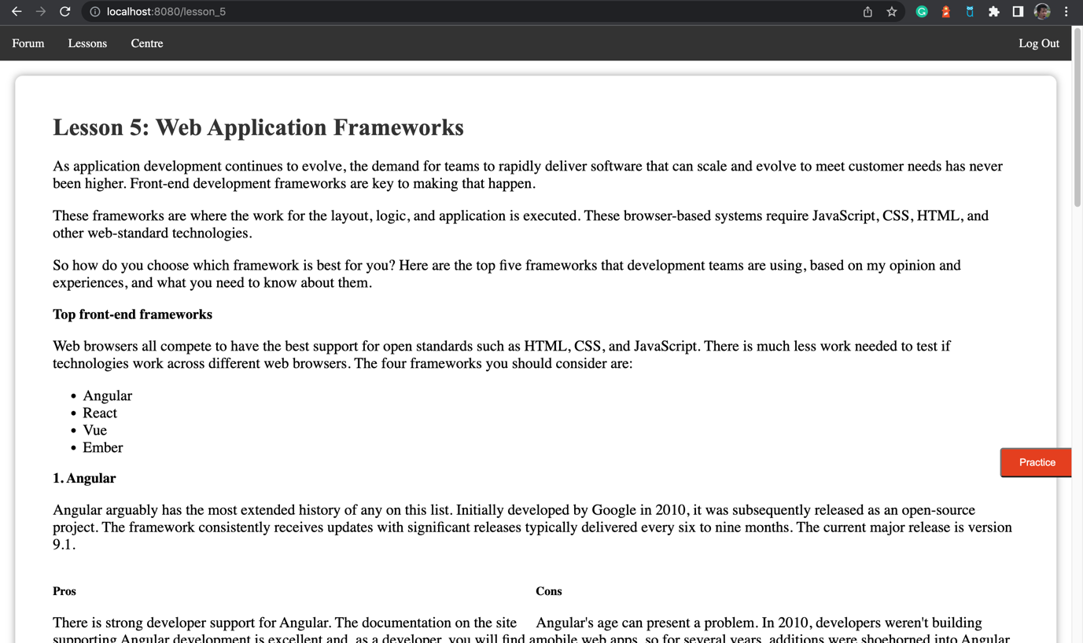

User-Based Evaluation on Website – Second Iteration

Compare the Usability test we did based on prototype, the test we do based on actual website covers more content since website includes more functionalities than prototype. This User-Based test is aiming for test if the participant can do All the tasks based on implemented functionalities without and problem.

we prepared a task list for the participant:

1. Register an account
2. Log in
3. Change password
4. Find message list
5. Add a new Friend “klaus”
6. Send a message to your new friend
7. Find the discussion forum
8. Make comment under a post
9. Make a new post

10. View the post you just made

11. Make comment under your post

12. Delete the Post you just made

13. Find Lesson1: Introduction to Web Development

14. As an Admin, mute “klaus”

15. As an Admin, add a new student called “student2”

16. As an Admin, add a new Admin called “admin2”

17. As an Admin, delete “student2”

18. As an Admin, delete “admin2”

19. log out

The usability testing are taken remotely. We made the testing over Zoom and we sent the participant all of the prototypes in advance so that he can try all the functions he need. We then asked him to perform each task, and the implications were that he found most of the tasks pretty easy.

Redefine Interface Design Guidelines

After this test, interviewee gave us the feedback that:

1. Image on Login Page is too large which reduce accessibility.

2. Users can post different post content with same post title, that makes our interviewees confused.

3. Current “send message” function is separate with “view message” which is hard to use. Interviewees can only send or view messages in different pages, they want these two functions in the same page.

4. There is no add friend function, by default: the way to add a friend is to send a message to him/her. That’s confused for users who looking for an “Add Friend” button.

Modifications based on Users’ feedback - Second Iteration

After received feedback from users, we start to make changes on our website implementation based on their feedback and suggestion.

Firstly, we change the photo on login page to make it accessible.

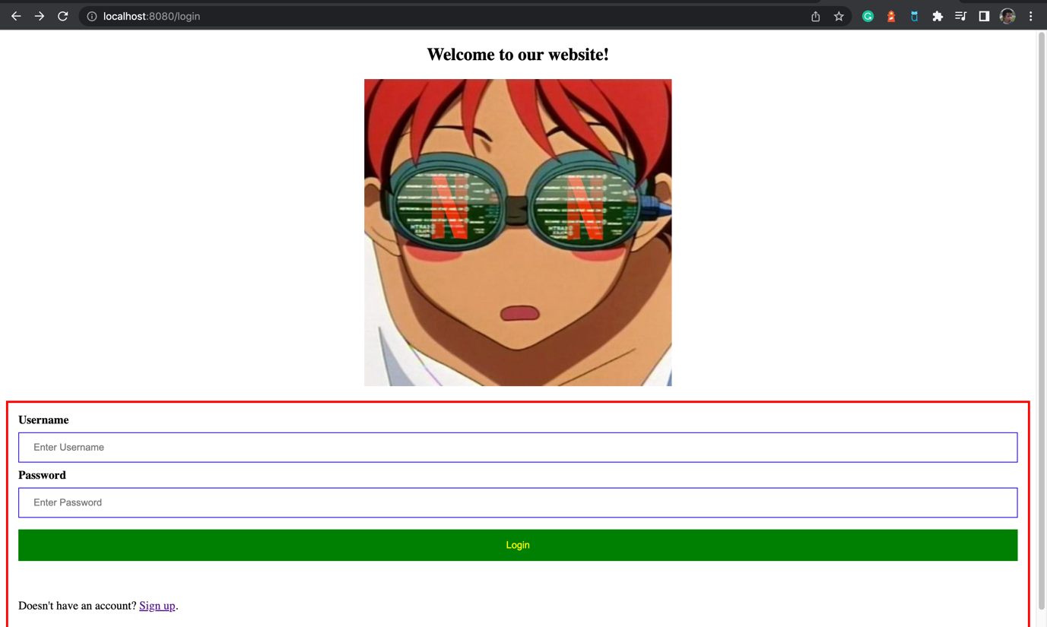

Secondly, we modify the send message page to add friend page to make the interface look more clear and easier to understand.

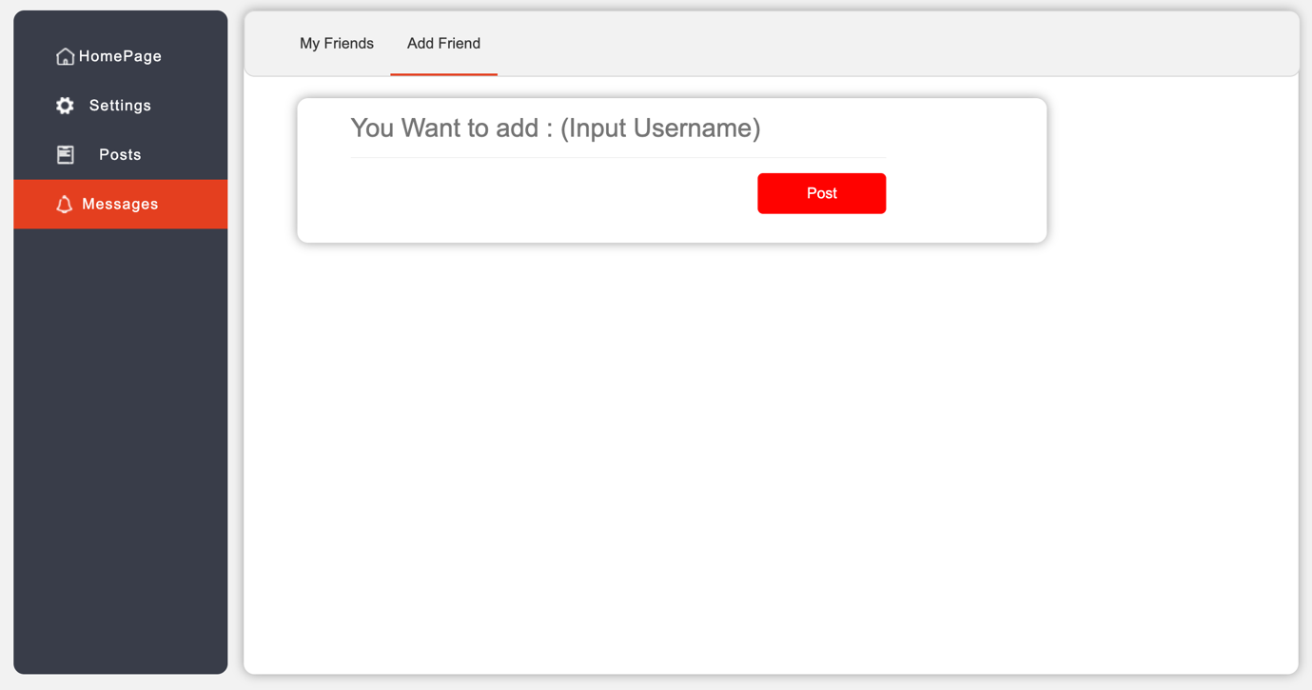

If users send a message to a user that doesn’t exist, we will not show any warning, we just don’t send the message and won’t update the database. Now we add a warning page to show the warning if user send message to a user doesn’t exist or add a friend which doesn’t exist.

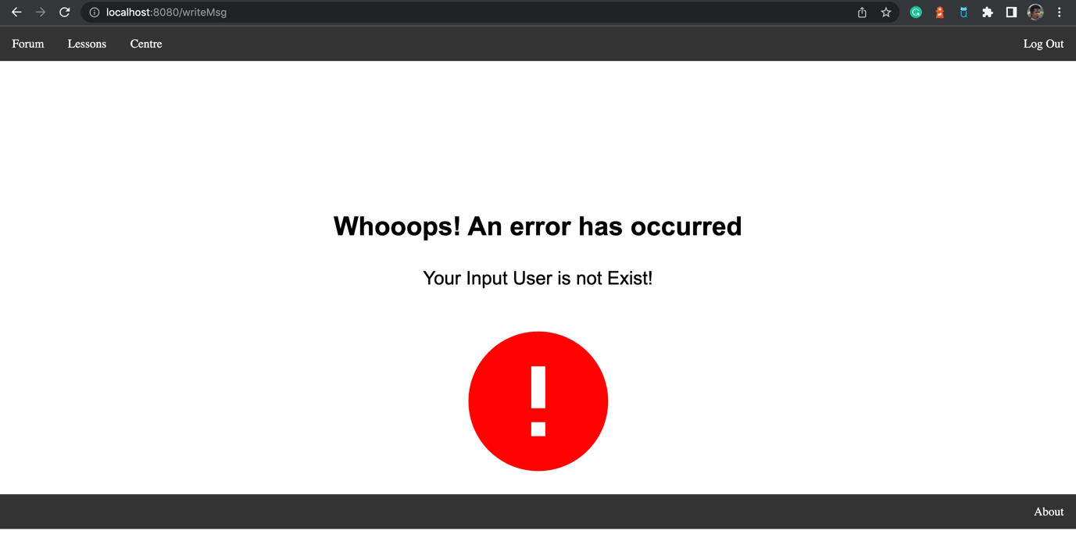

Otherwise, if users input the existed username, it will show the page below.

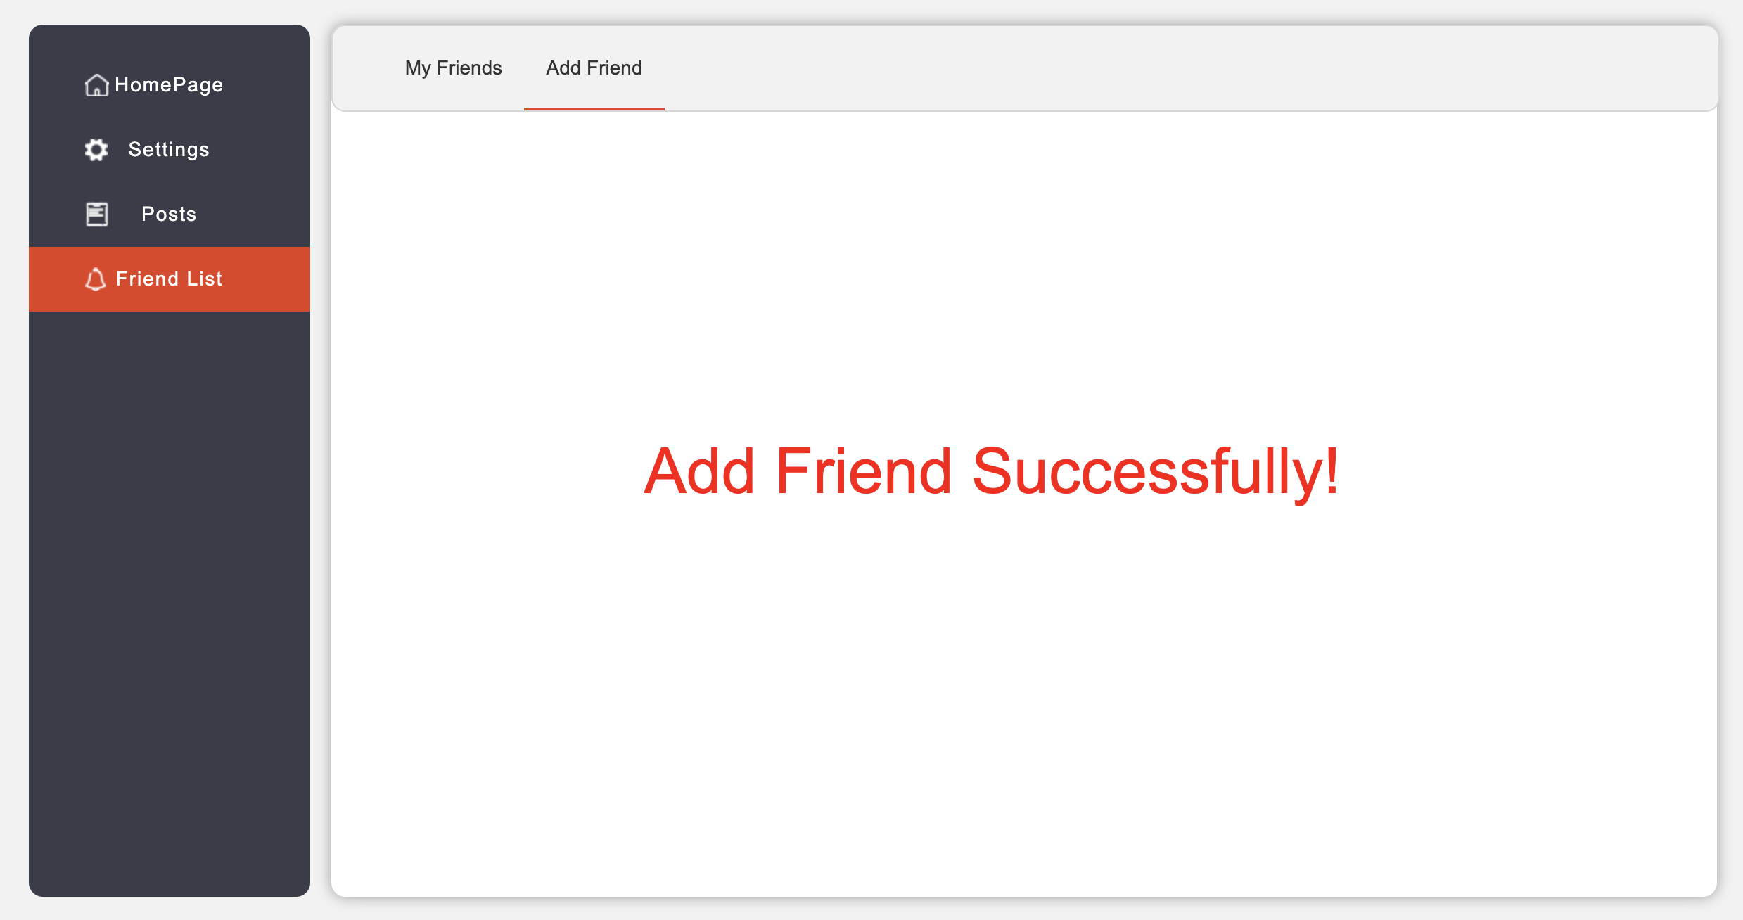

We still use the friend list page to demonstrate the user’s friend.

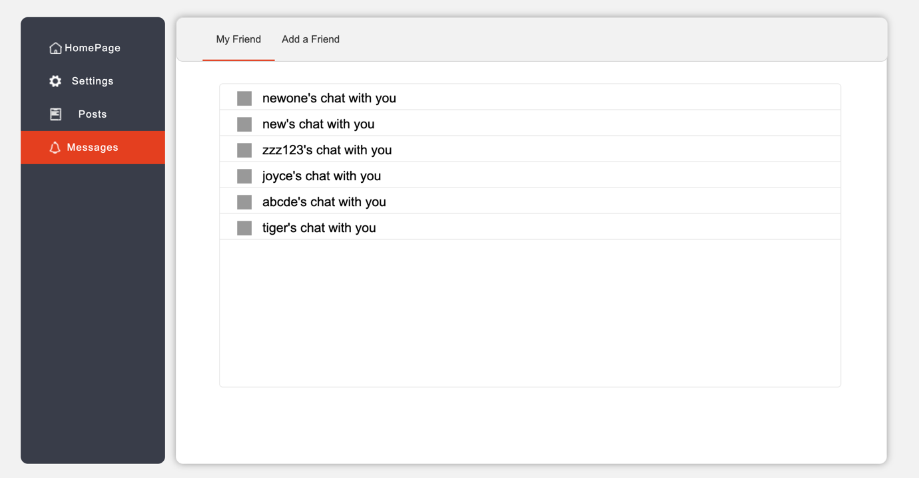

But after you click in to a friend’s page, we make the send message function in the same page with the view message page.

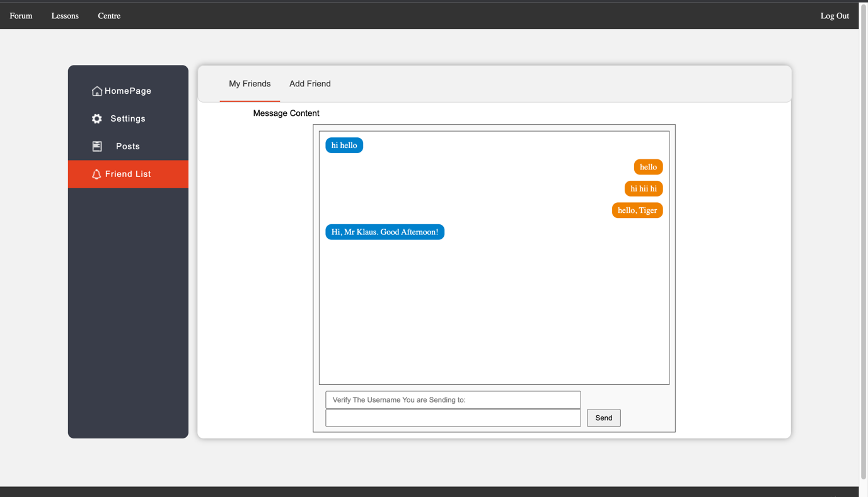

Also, we add another warning page that if you want to make a post with same title as existing posts.

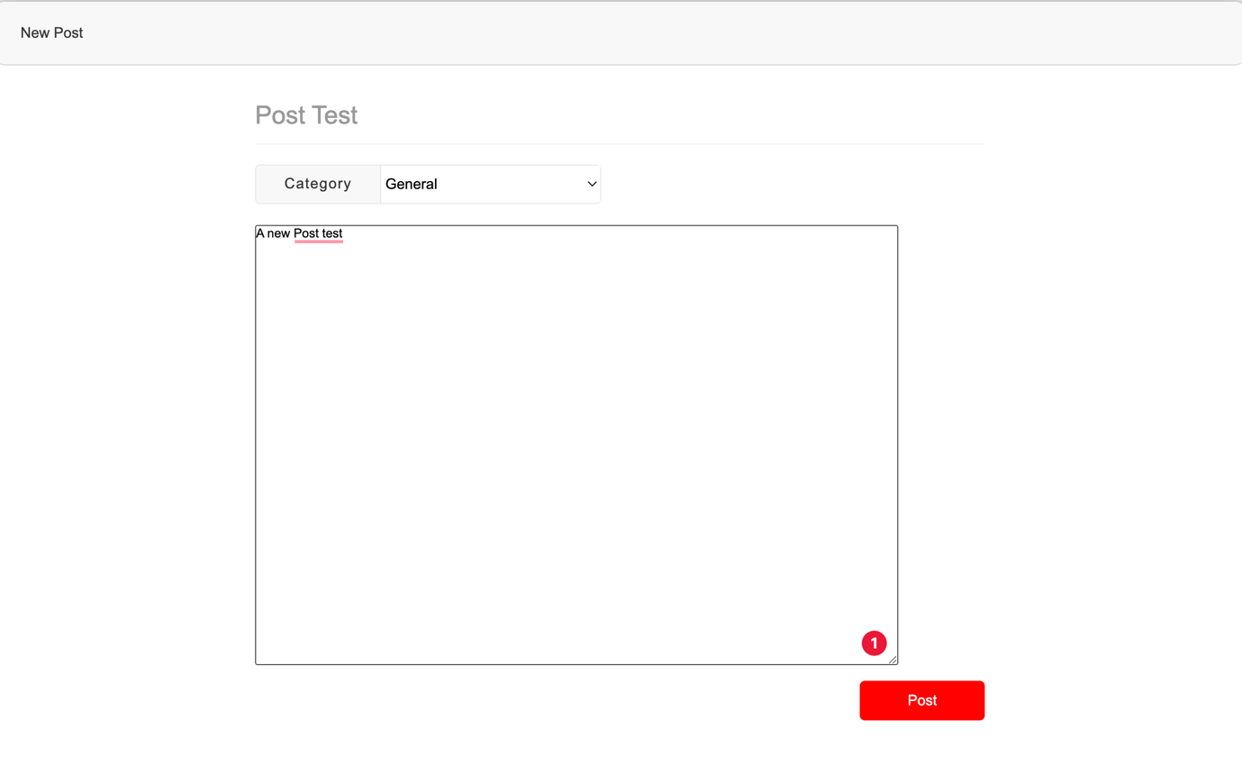

It will jump out a warning shown below.

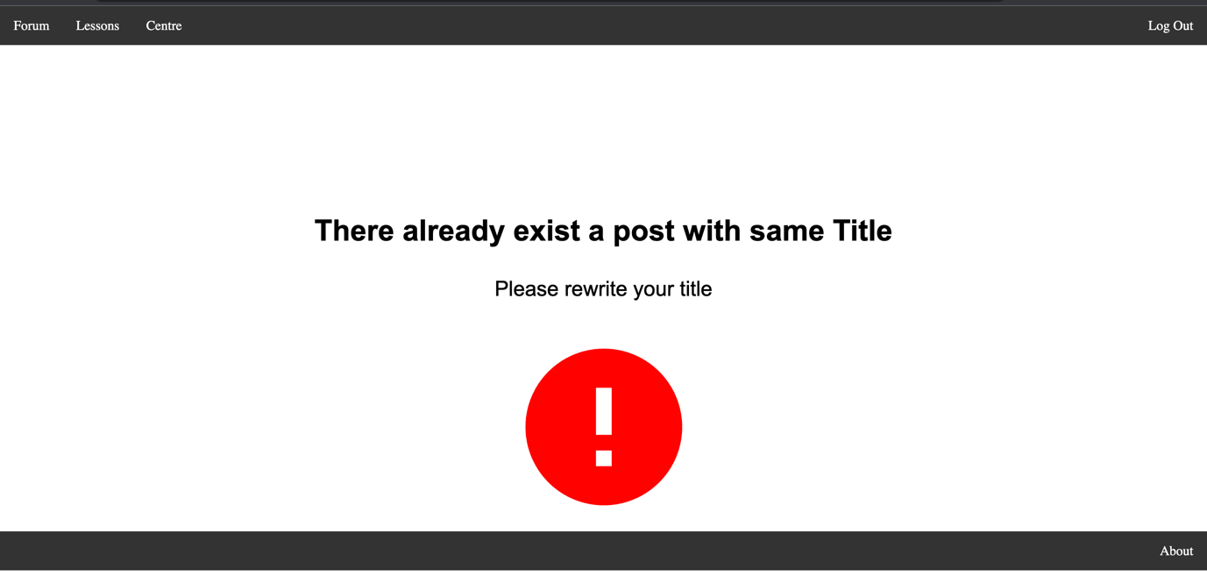

Also, we add the “next lesson” and “previous lesson” button in the lessons page.

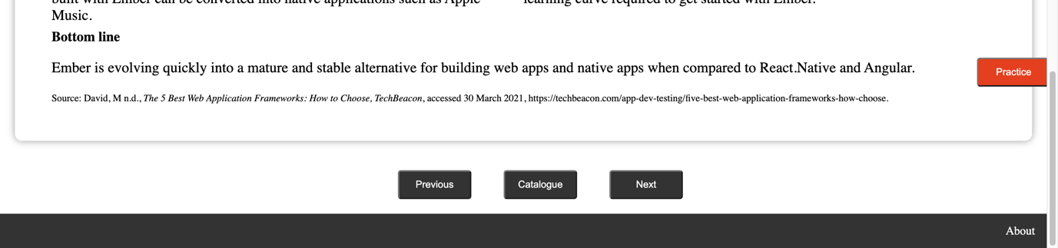

Accessibility Test

In order to tesr our website’s accessibility, we use lighthouse for testing. Here are the test results:

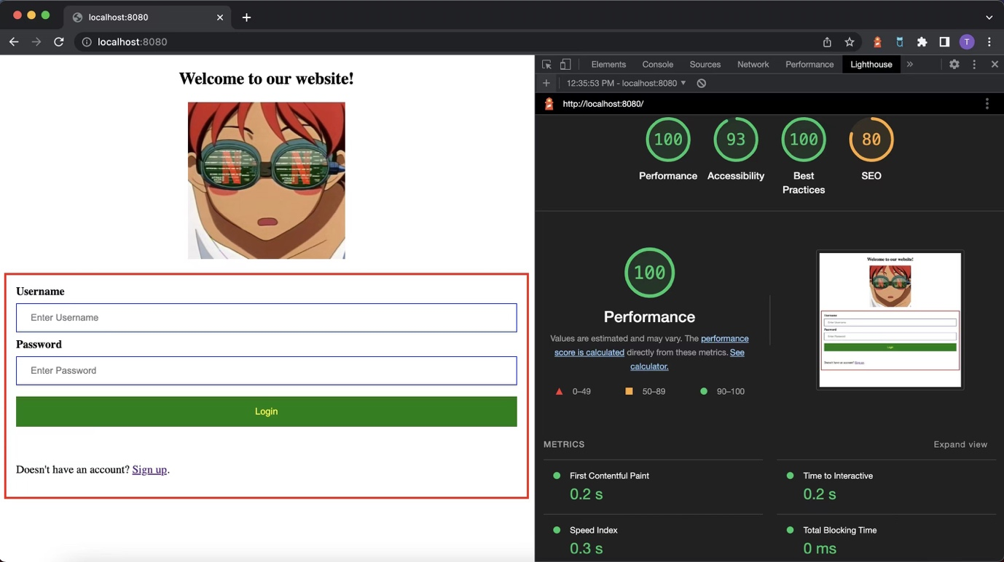

Login Page General Test Result

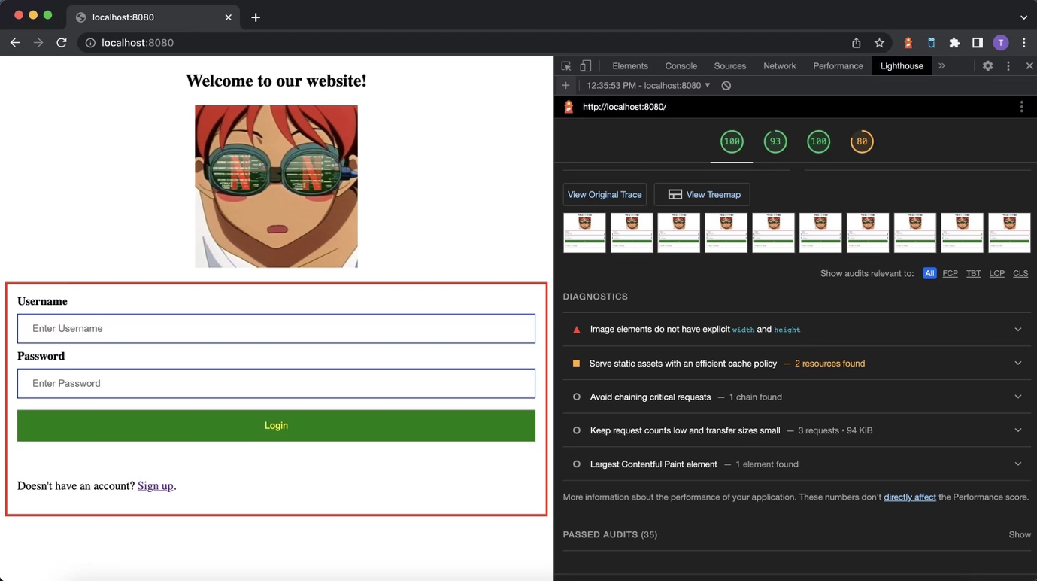

Login Page General Test Result

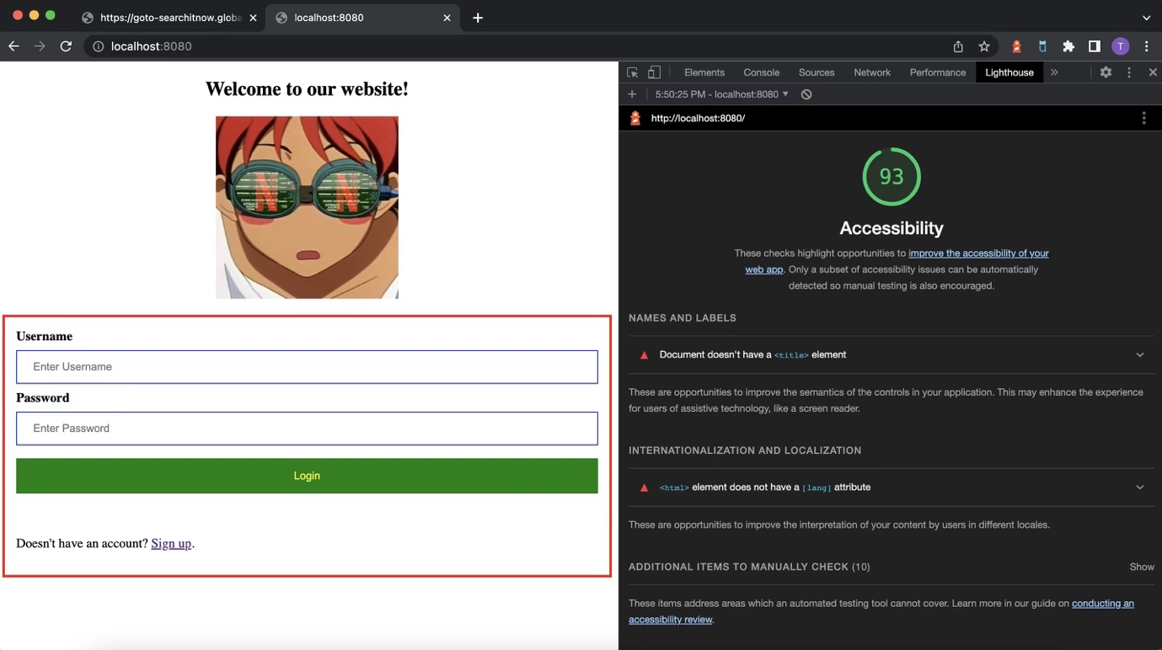

Login Page Accessibility Test Result

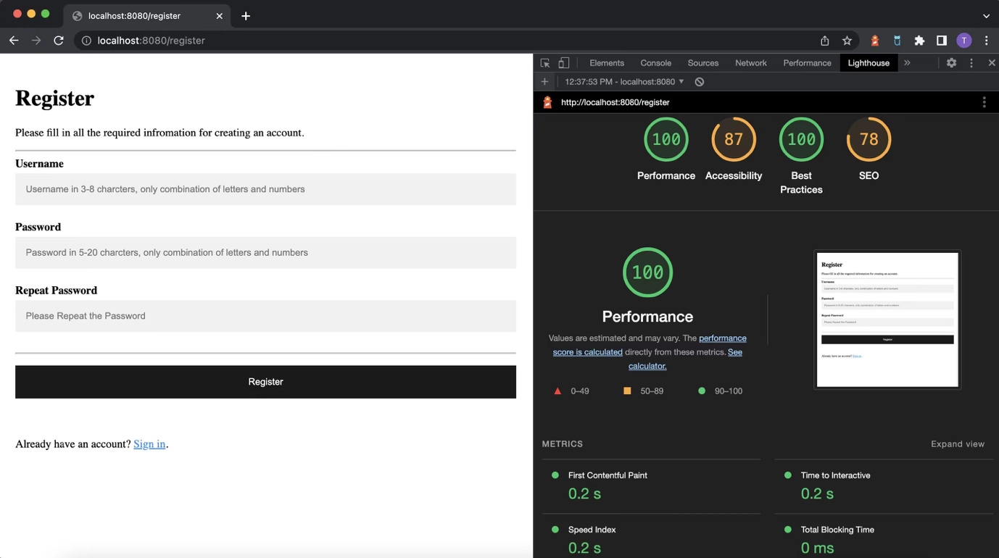

Register Page Accessibility Test Result

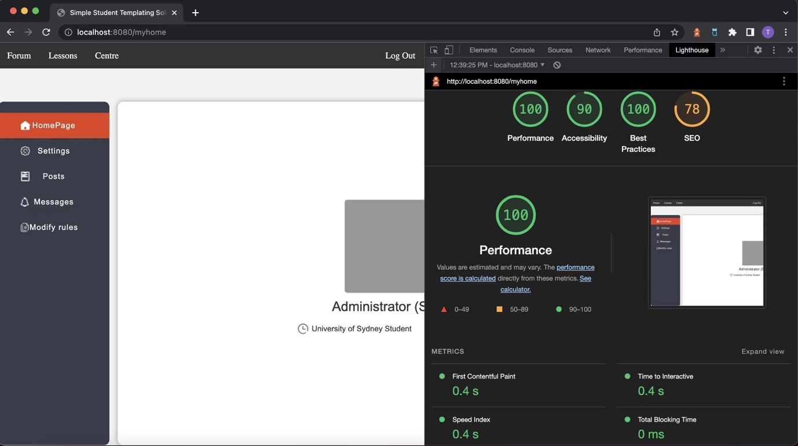

Profile Page Accessibility Test Result

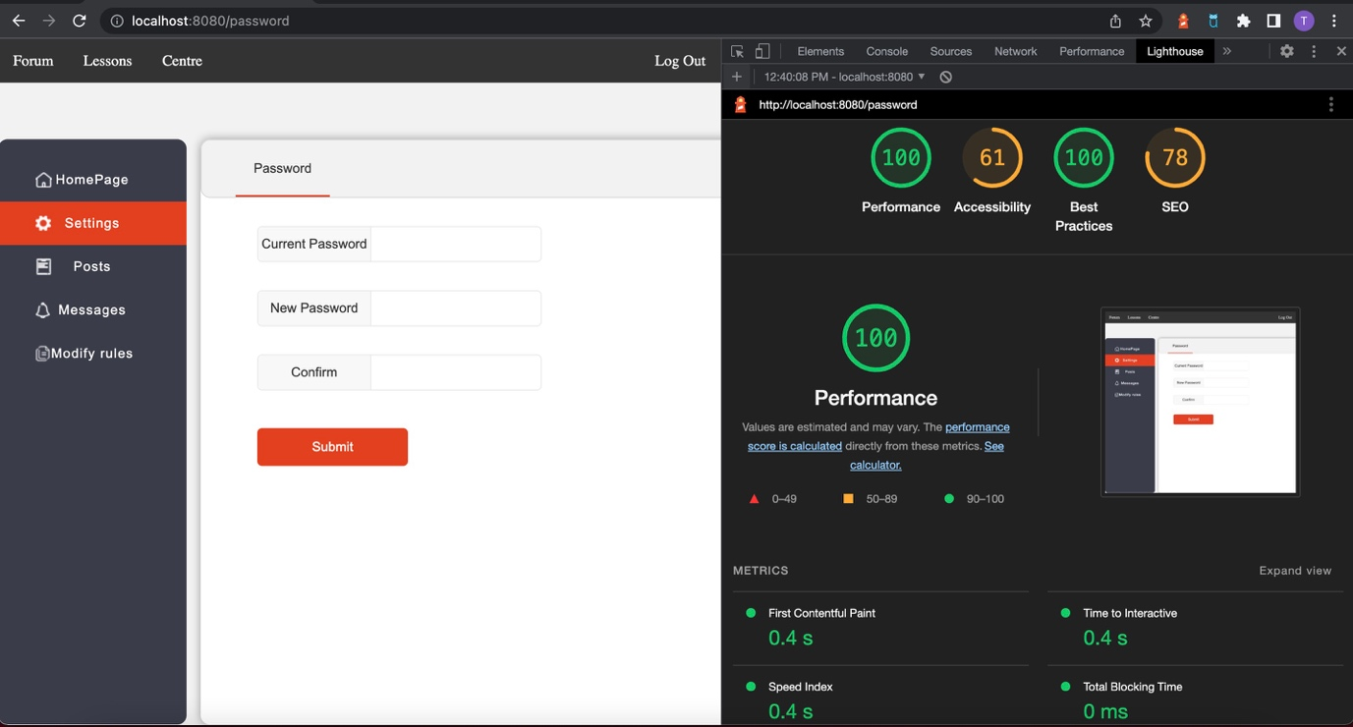

Setting Page Accessibility Test Result

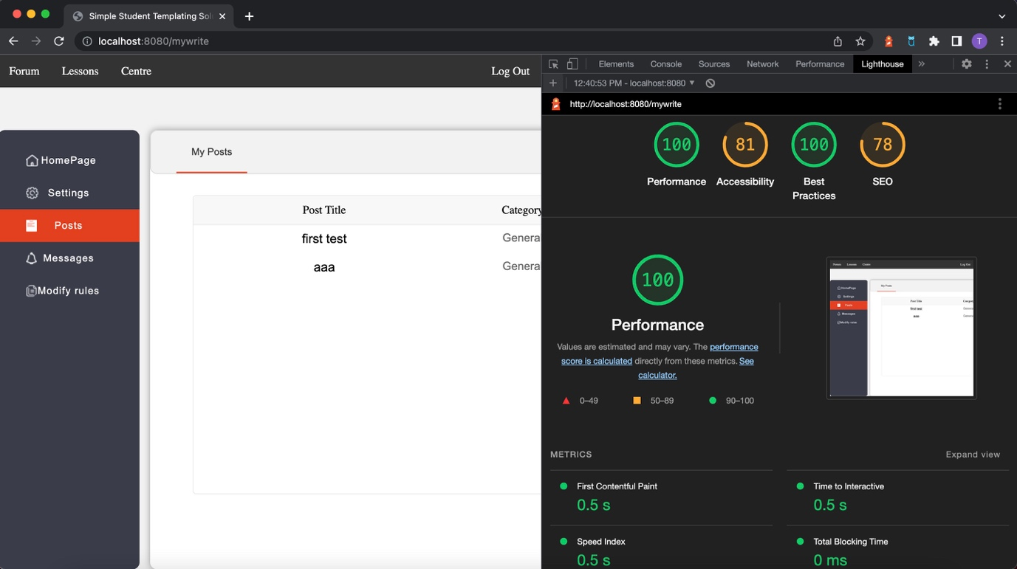

Post Page Accessibility Test Result

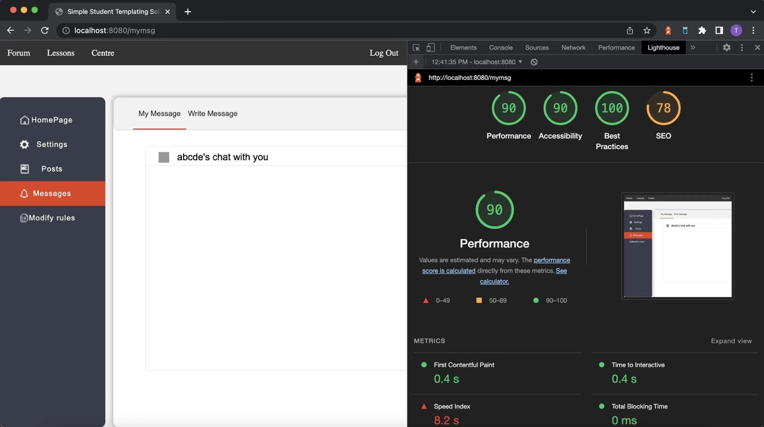

Message Page Accessibility Test Result

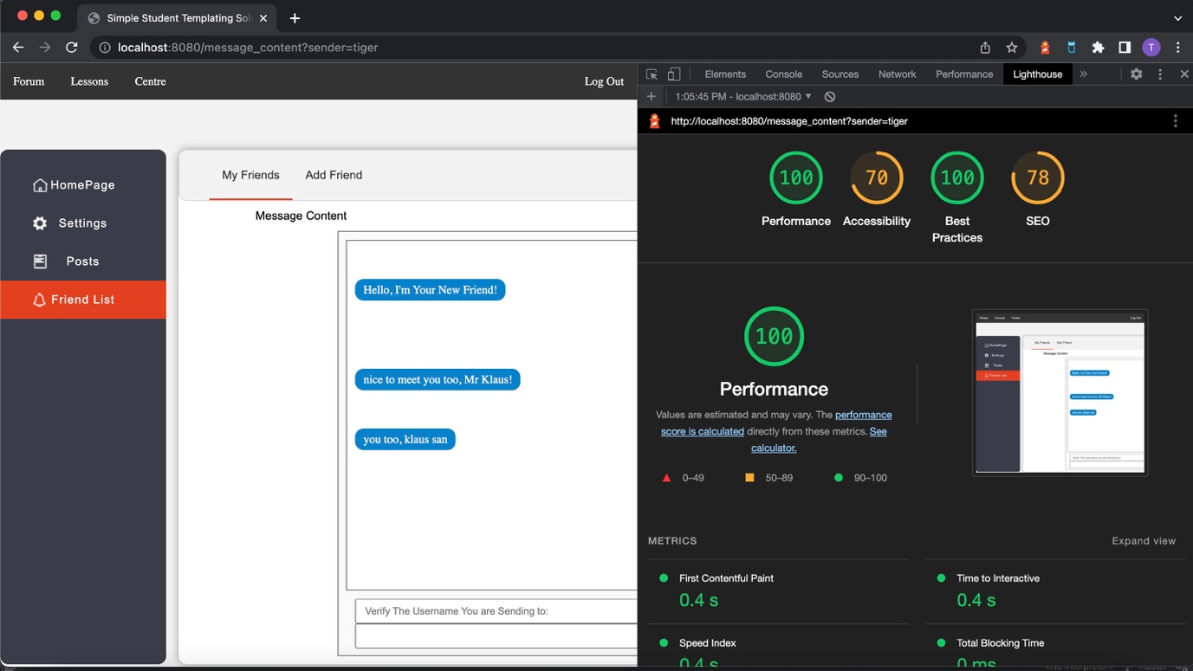

Write Message & Message Content Page Accessibility Test Result

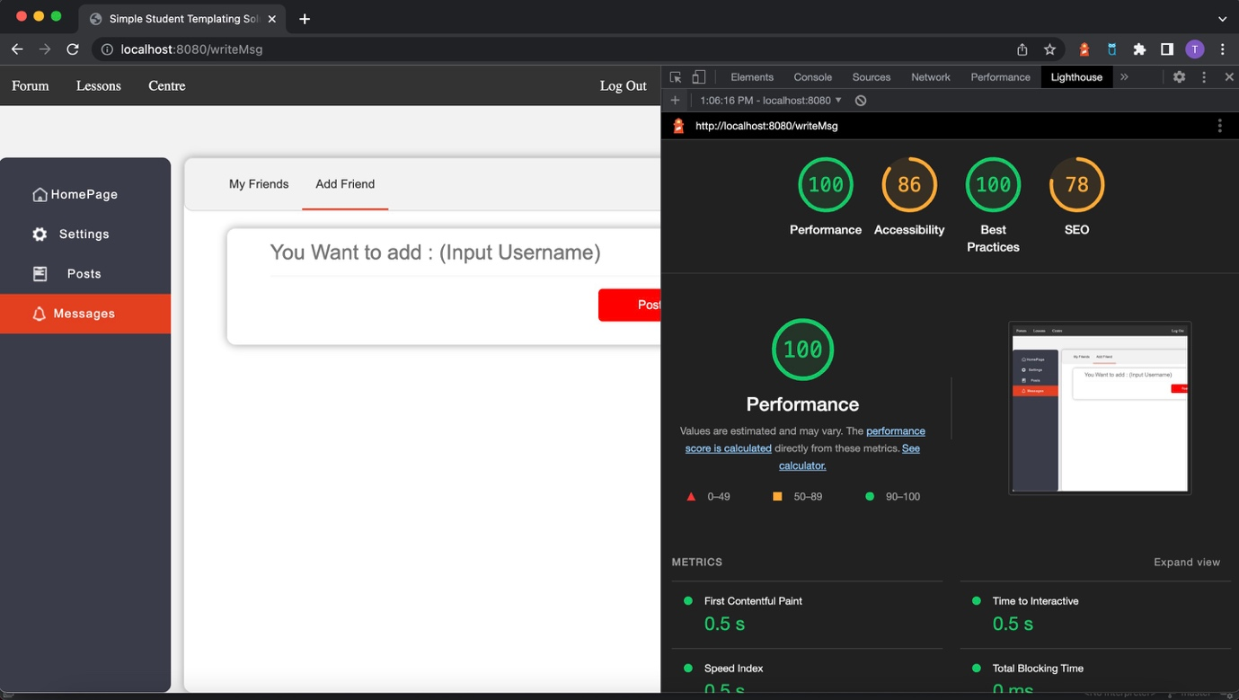

Add Friend Page Accessibility Test Result

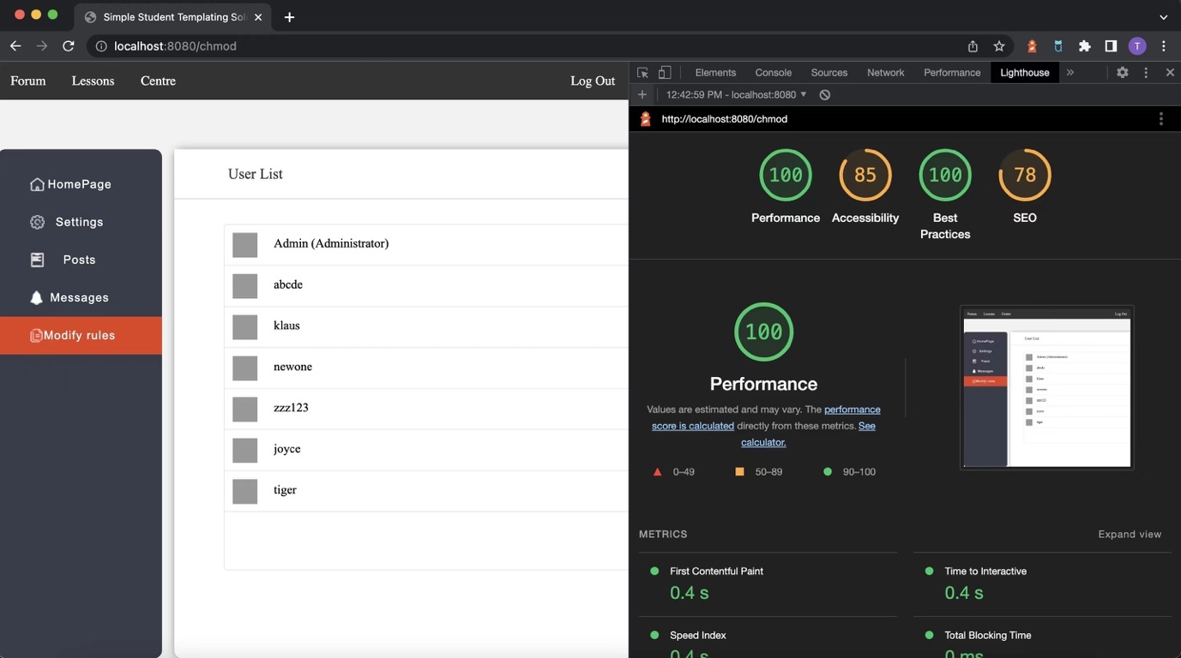

Admin Modify Page Accessibility Test Result

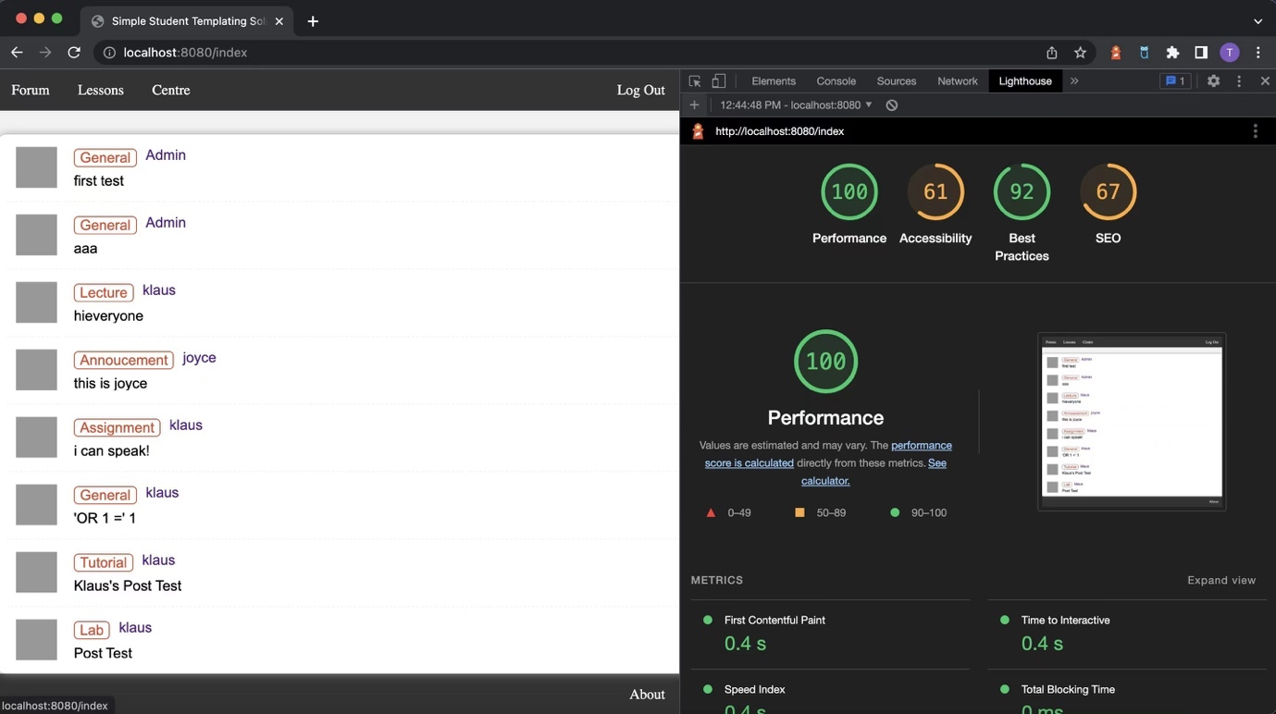

Forum Posts Page Accessibility Test Result

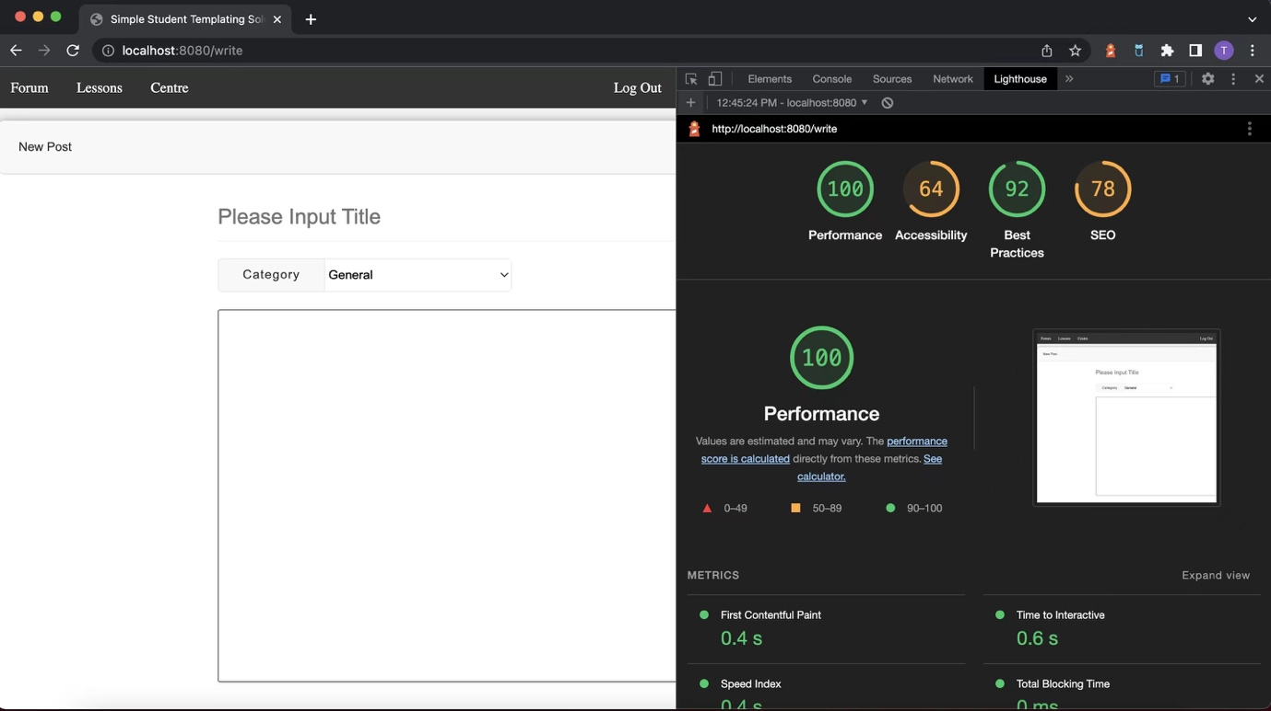

Write Post Page Accessibility Test Result

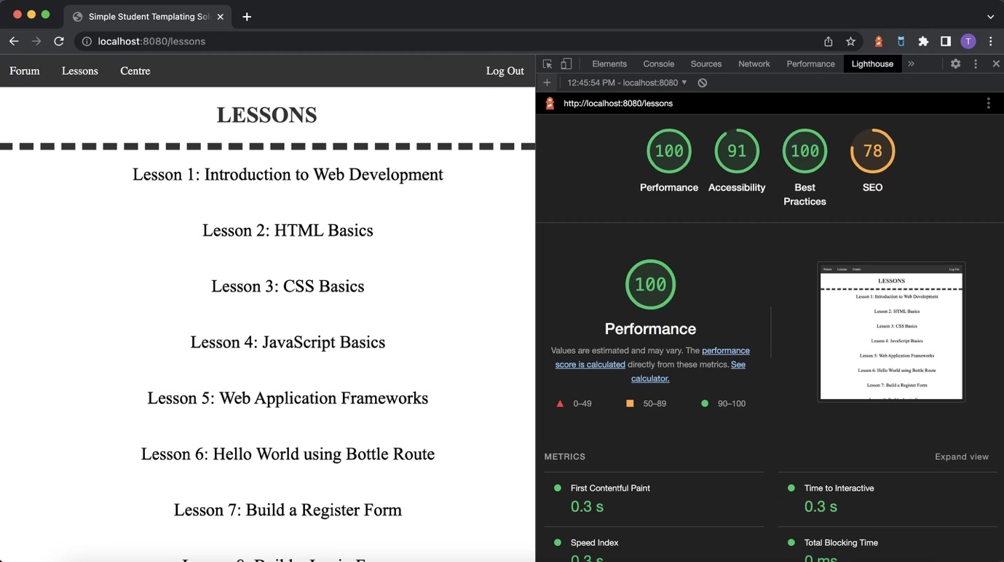

Lessons Page Accessibility Test Result

Conclusion

The final version of the website includes all of the required core features for the project: login, register, user personal profile, changing password, Admin role, user role, message box, and a well-designed forum named course with comment functionality. With the help of our survey and card sorting results, we conduct the prototype which later supporting us get the useful user feedback from the guerrilla test. Eventually, we finalized our final website and the overall feedbacks from the end-user in the second iteration shows that it is fairly easy for them to navigate through the website.

Regrading to the limitation: Under the influence of the epidemic, we did find it is challenging to perform guerrilla test and receiving useful information from the test. We believe guerrilla test will be more affective and benefit if we could do it in-person as it is easier to communicate when facing the participants and directly see their reactions when accessing the website. Moreover, if guerrilla test could be held off-line, we may get more feedback as many people declined our online invitation.

References

Knowledge Base

Lesson 1: CareerFoundry n.d. *Tutorial 1: An Introduction to Web Development*, accessed 30 March 2021, <https://careerfoundry.com/en/tutorials/web-development-for-beginners/introduction-to-web- development/>.

Lesson 2: HTML n.d., *HTML For Beginners The Easy Way: Start Learning HTML & CSS Today*, accessed 30 March 2021, <https://html.com/>.

Lesson 3: Mozilla n.d., *CSS Basics*, MDN Web Docs, accessed 30 March 2021, <https://developer.mozilla.org/en-US/docs/Learn/Getting_started_with_the_web/CSS_basics >.

Lesson 4: TutorialsPoint n.d., *JavaScript Tutorial,* accessed 30 March 2021, <https://www.tutorialspoint.com/javascript/index.htm>.

Lesson 5: David, M n.d., *The 5 Best Web Application Frameworks: How to Choose*, TechBeacon, accessed 30 March 2021, <https://techbeacon.com/app-dev-testing/five-best-web-application-frameworks-how-choose >.

Lesson 6: Hellkamp, M 2021, *Bottle Tutorial*, Bottle: Python Web Framework, accessed 8 April 2021, < https://bottlepy.org/docs/dev/tutorial.html#dynamic-routes>.

Lesson 7 & 8: Tutorial Republic n.d., *PHP MySQL Login System,* accessed 30 March, <https://www.tutorialrepublic.com/php-tutorial/php-mysql-login-system.php>.

Codes

For the usability project, We use HTML, CSS, Python Bottle, SQL Database and JavaScript to do our code part.